Accessory Pouch Product Manual
Image | Description
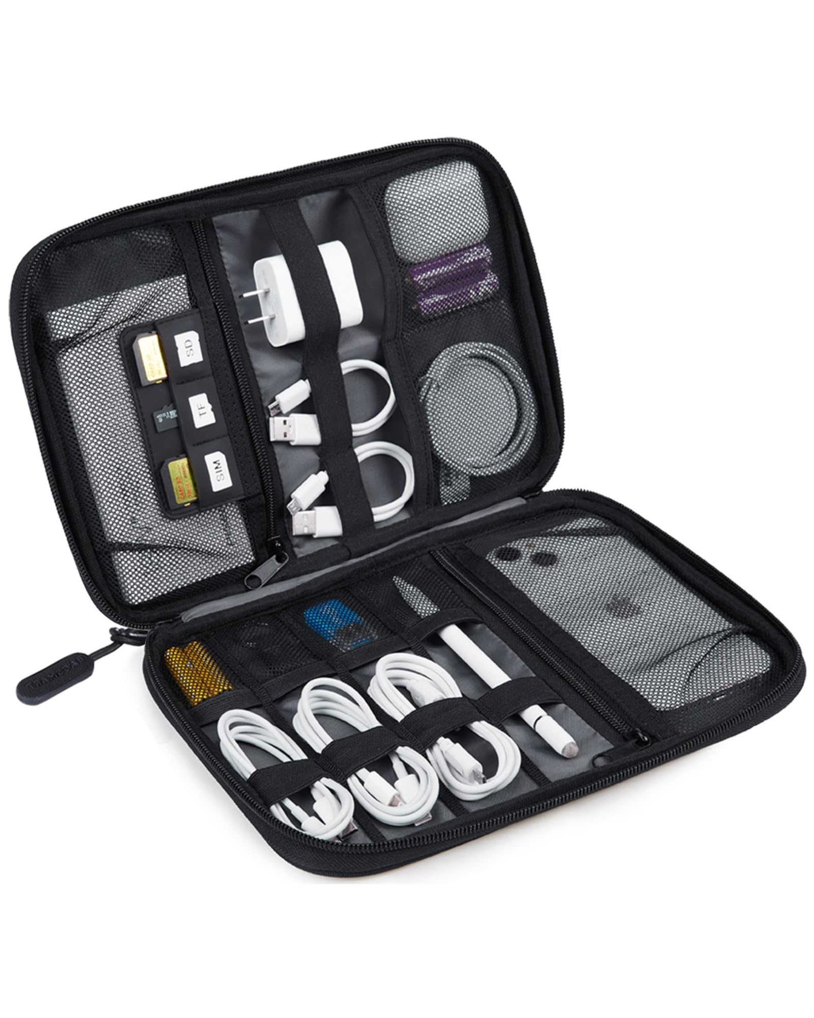 | This is a description of the accessory pouch, highlighting its features like organization, storage, and space-saving design.
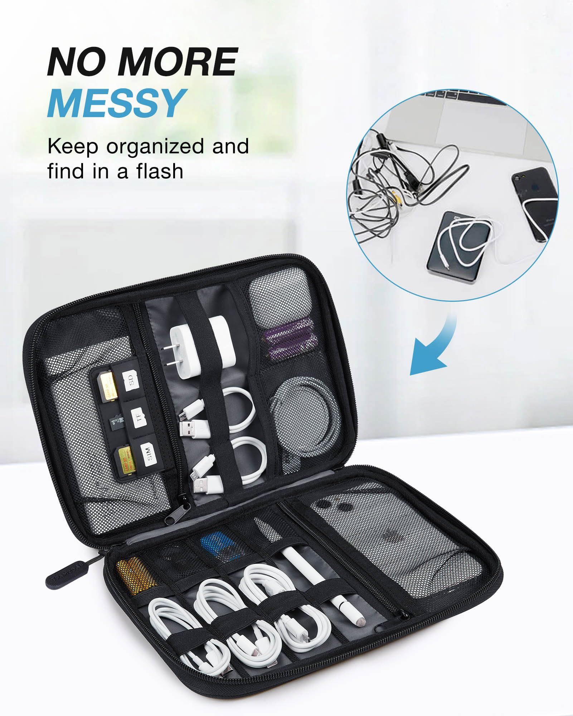 | This is a description of the accessory pouch, highlighting its features like organization, storage, and space-saving design.
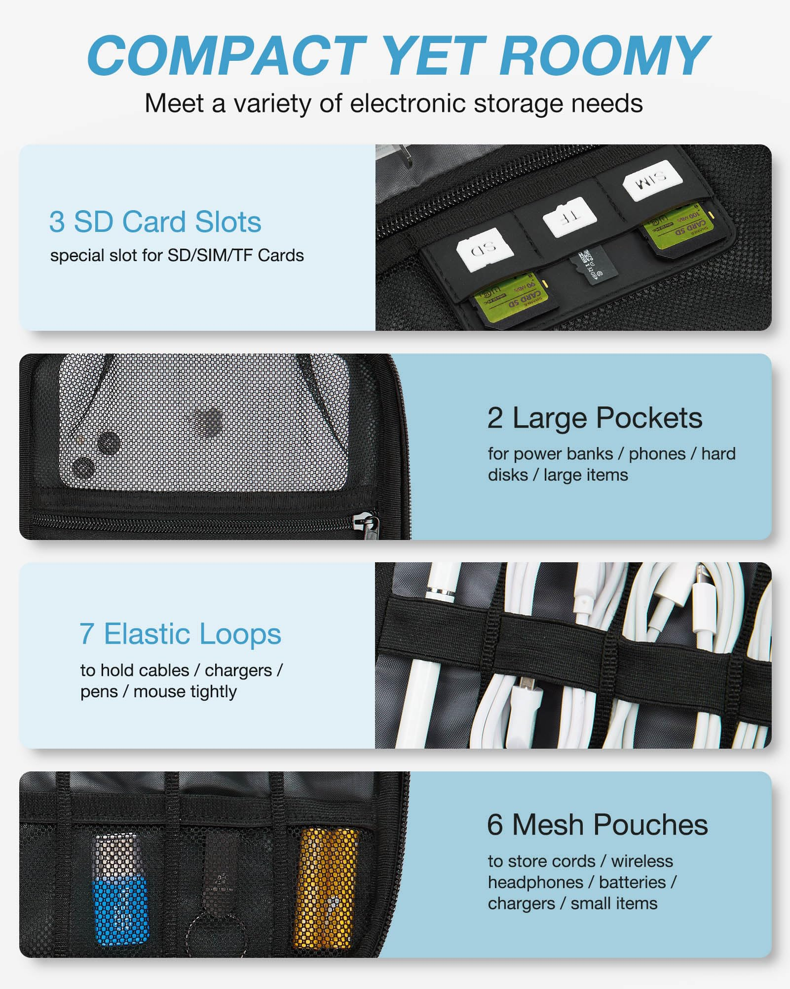 | This is a description of the accessory pouch, highlighting its features like organization, storage, and space-saving design.
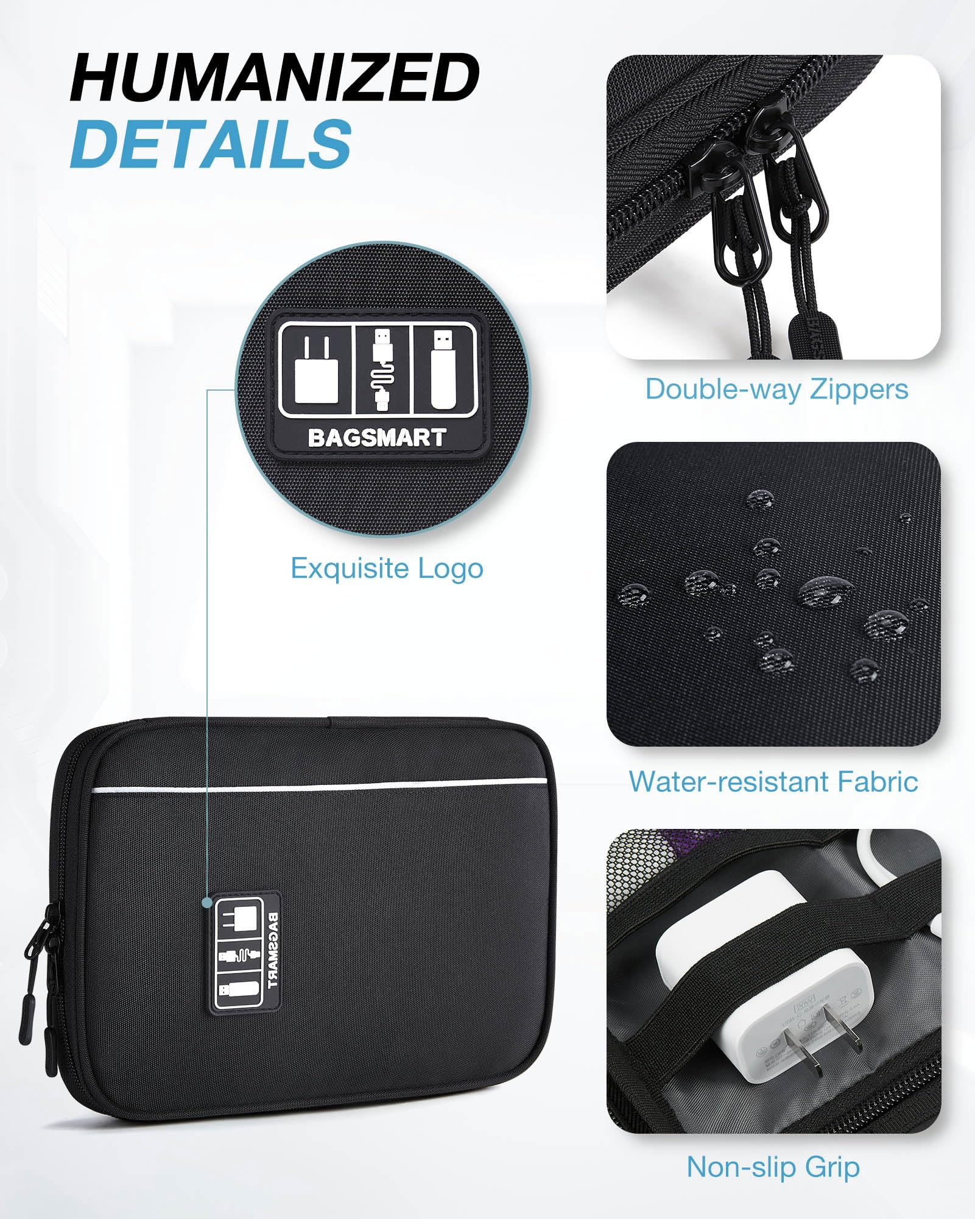 | This is a description of the accessory pouch, highlighting its features like organization, storage, and space-saving design.
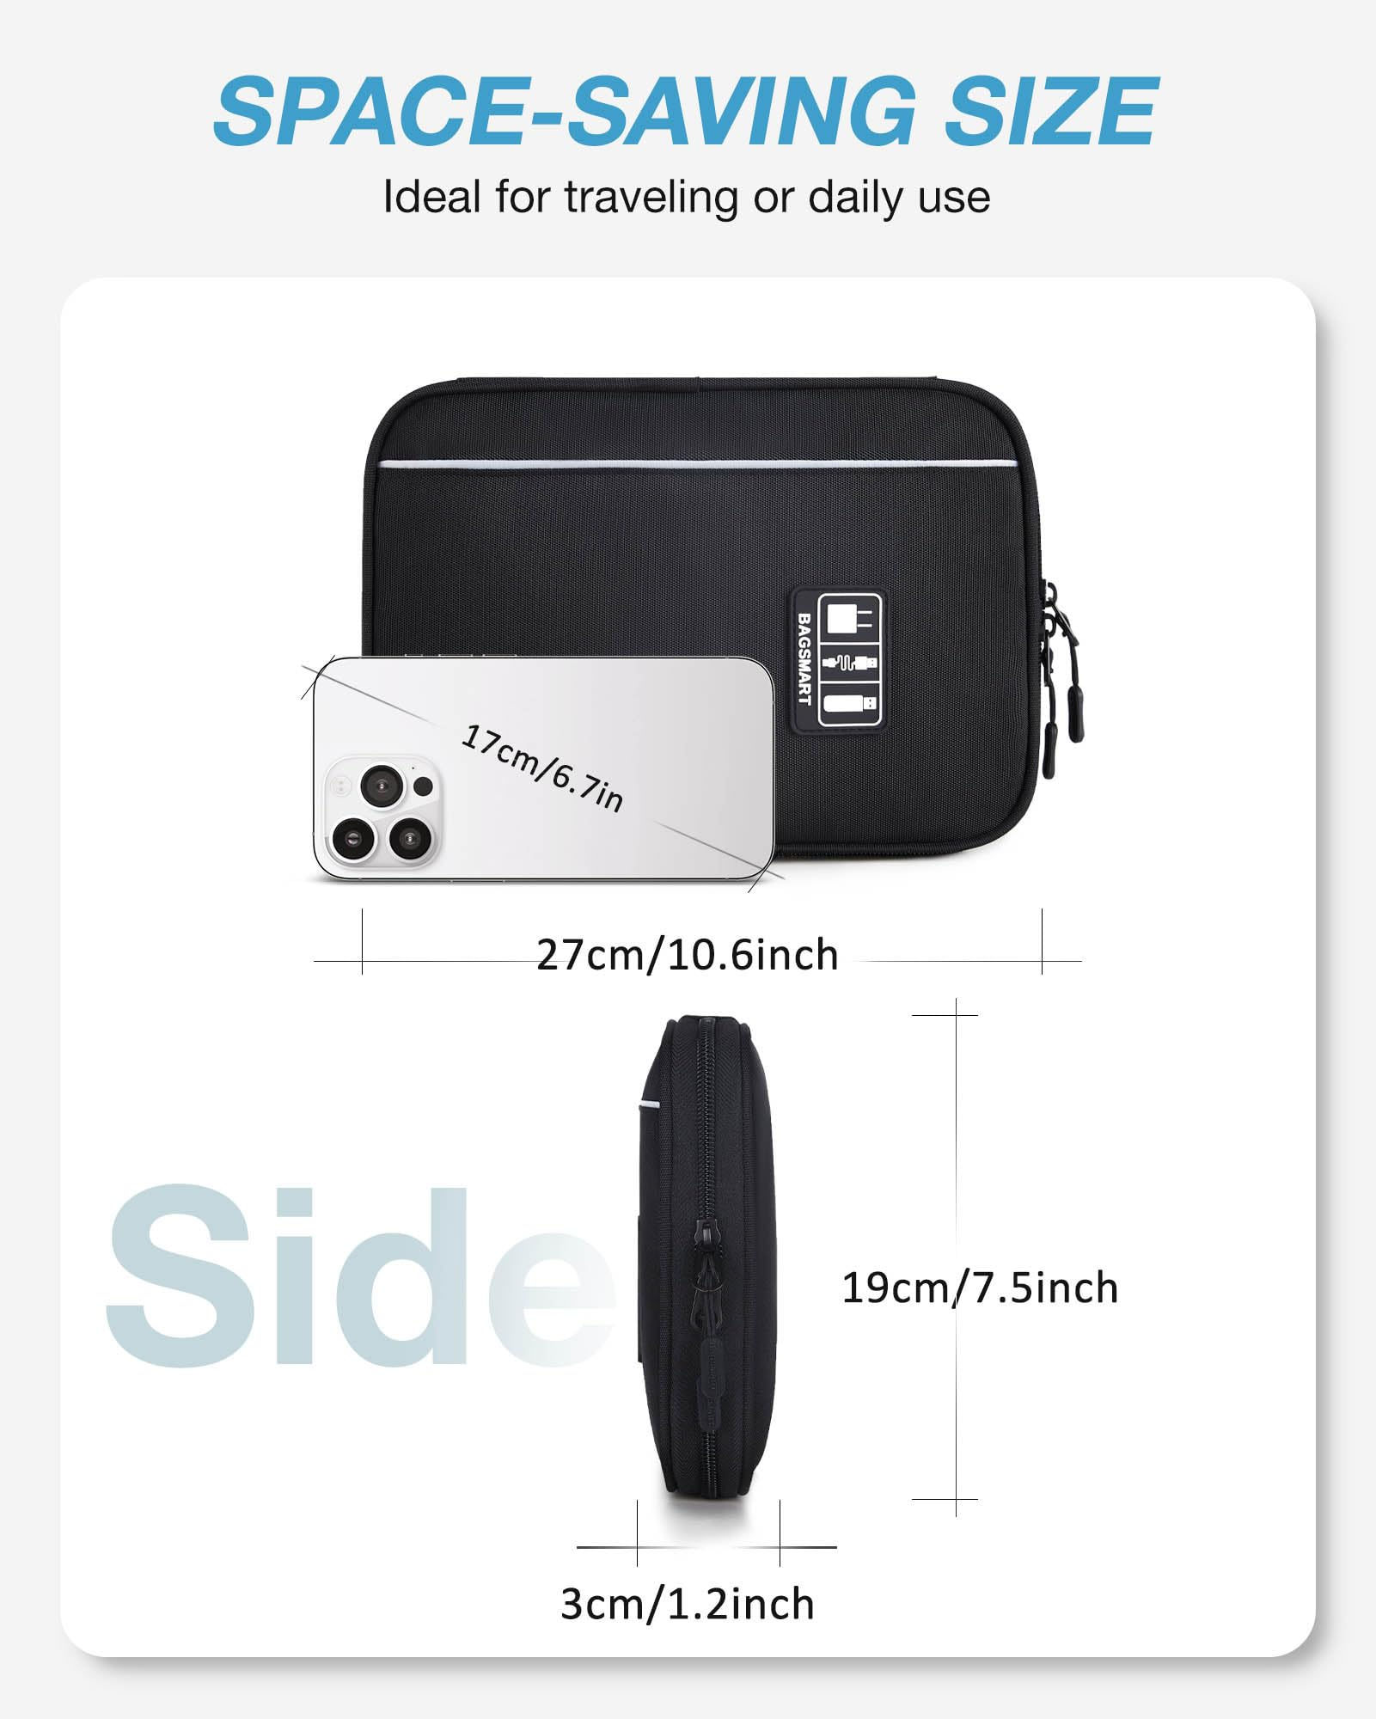 | This is a description of the accessory pouch, highlighting its features like organization, storage, and space-saving design.
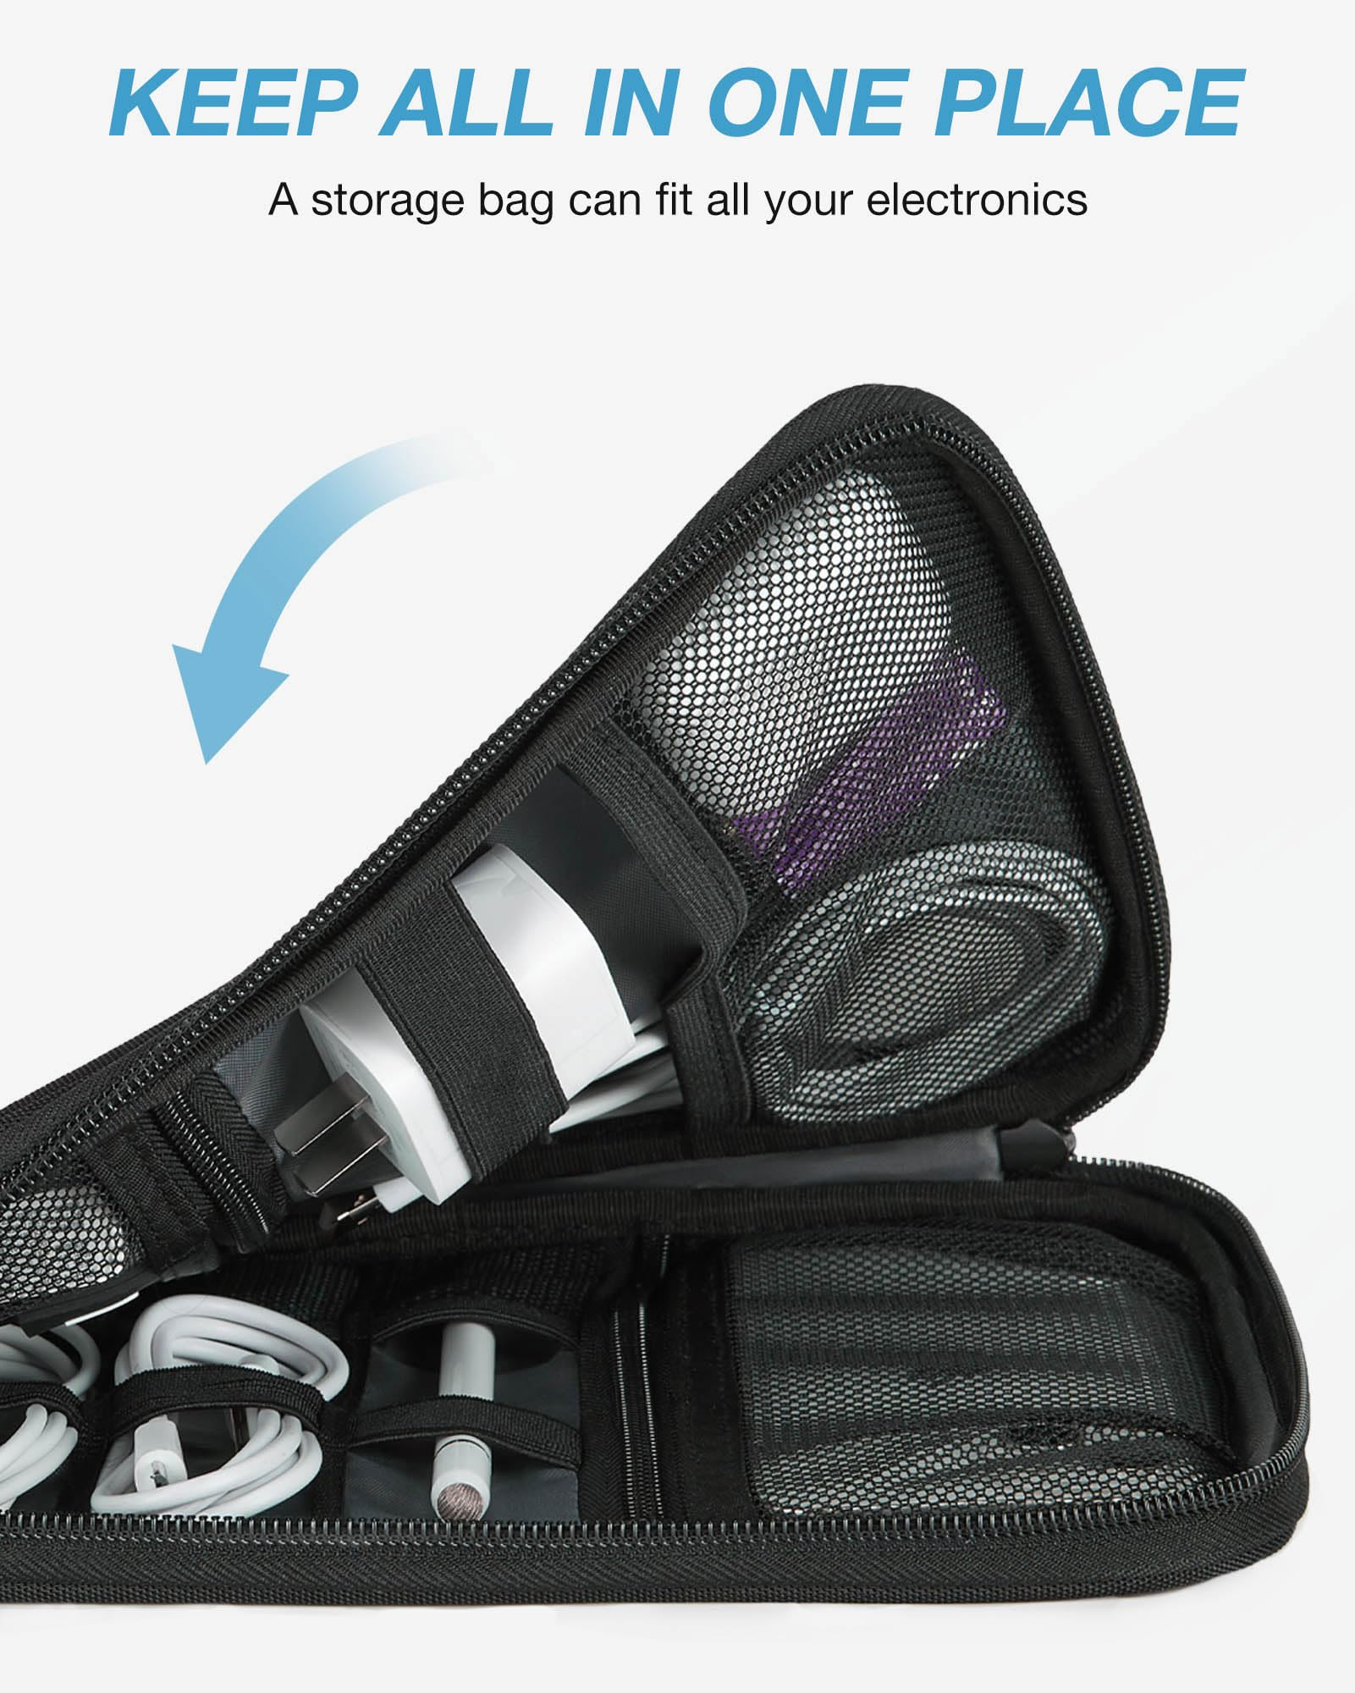 | This is a description of the accessory pouch, highlighting its features like organization, storage, and space-saving design.
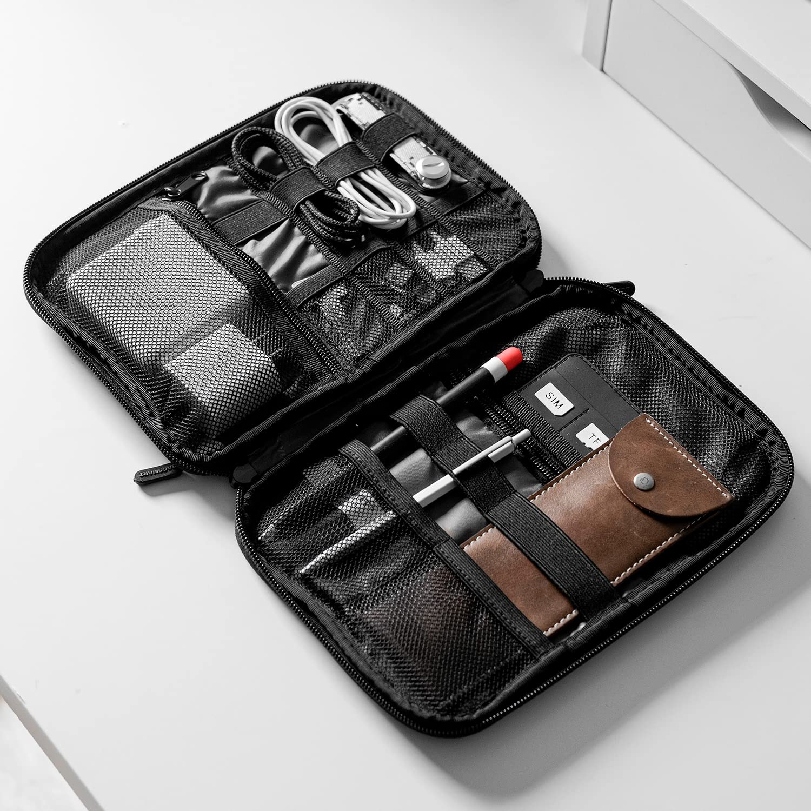 | This is a description of the accessory pouch, highlighting its features like organization, storage, and space-saving design.

