Laptop Backpacks for Women
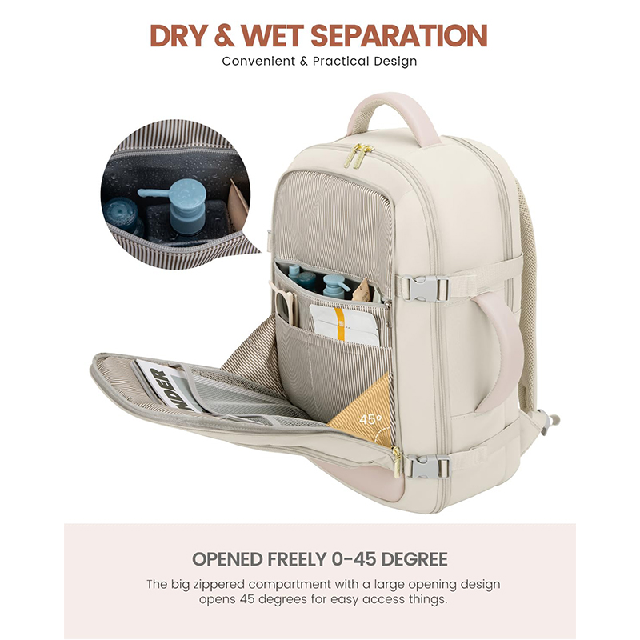 | Laptop Backpack Image 1
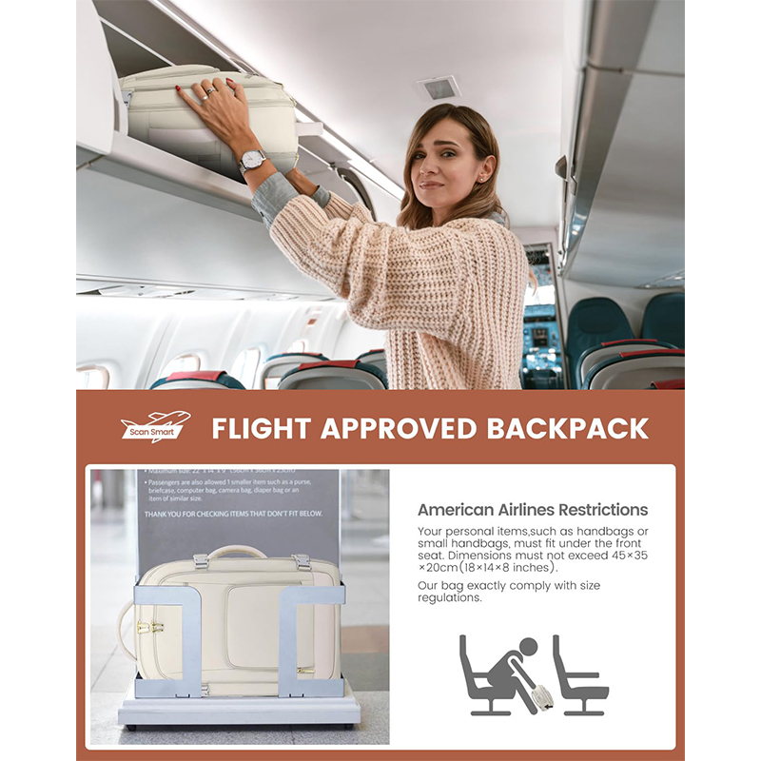 | Laptop Backpack Image 2
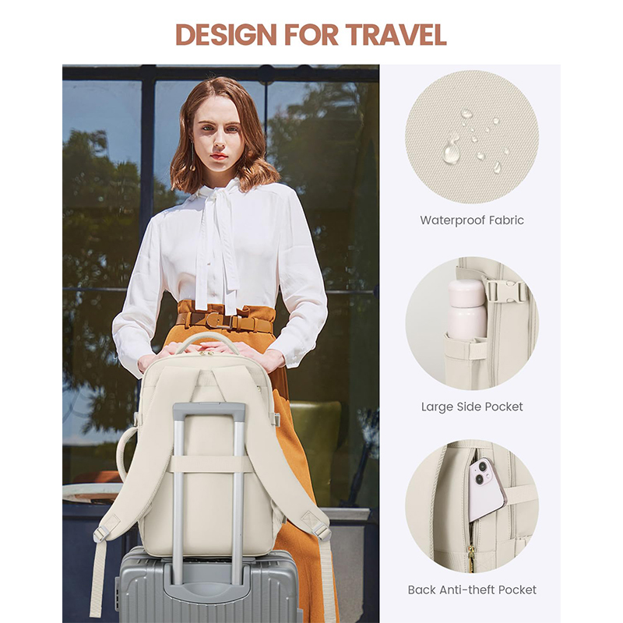 | Laptop Backpack Image 3
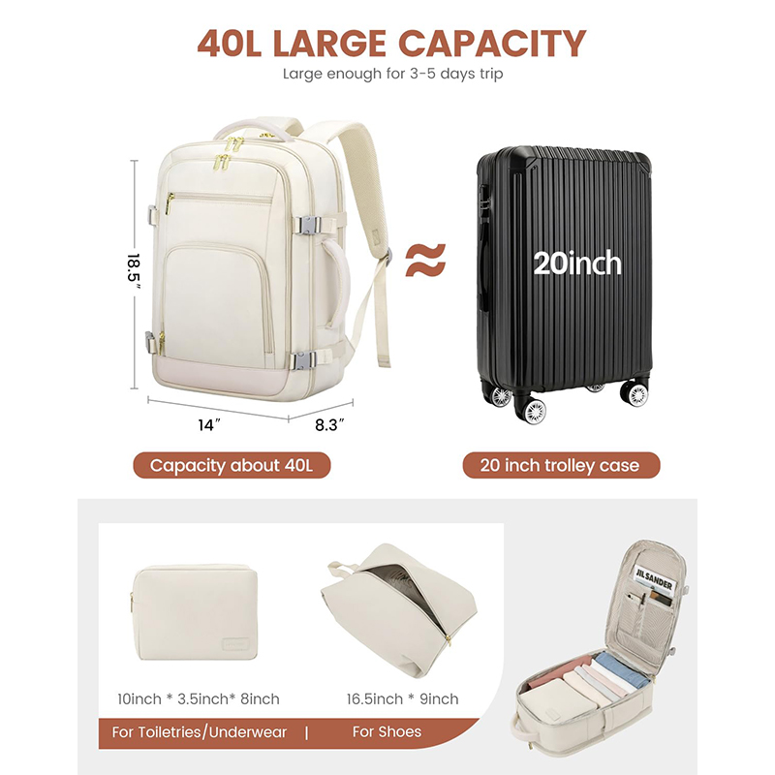 | Laptop Backpack Image 4
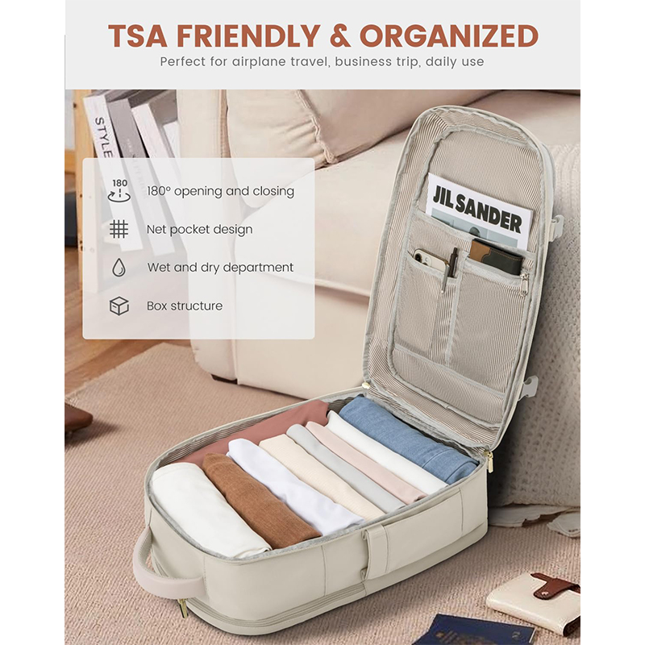 | Laptop Backpack Image 5
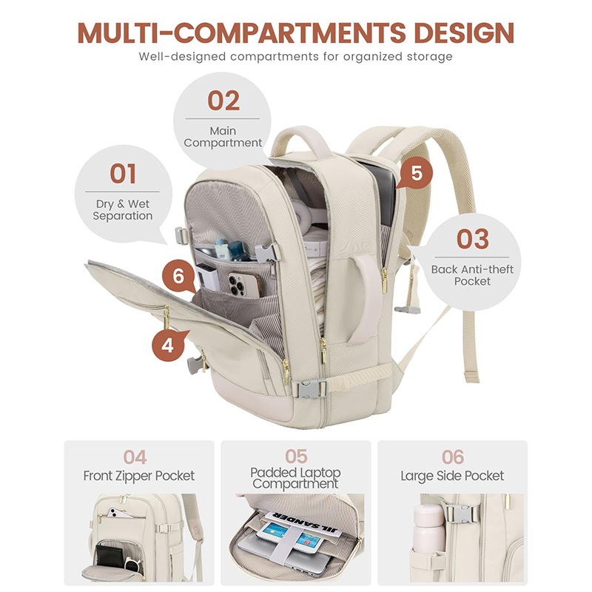 | Laptop Backpack Image 6
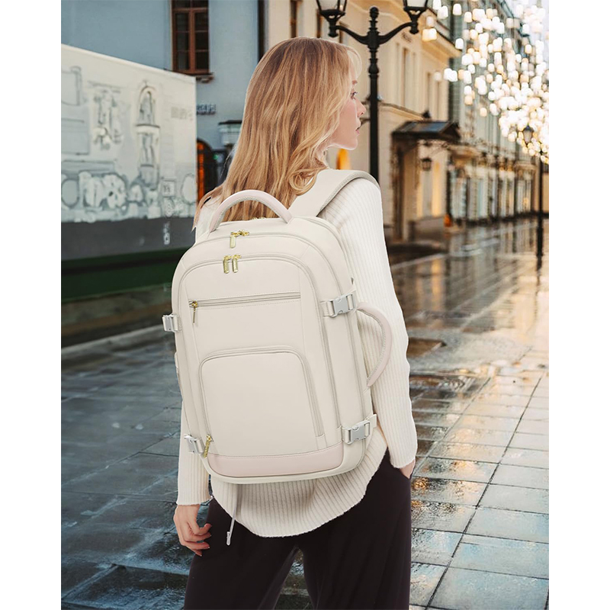 | Laptop Backpack Image 7
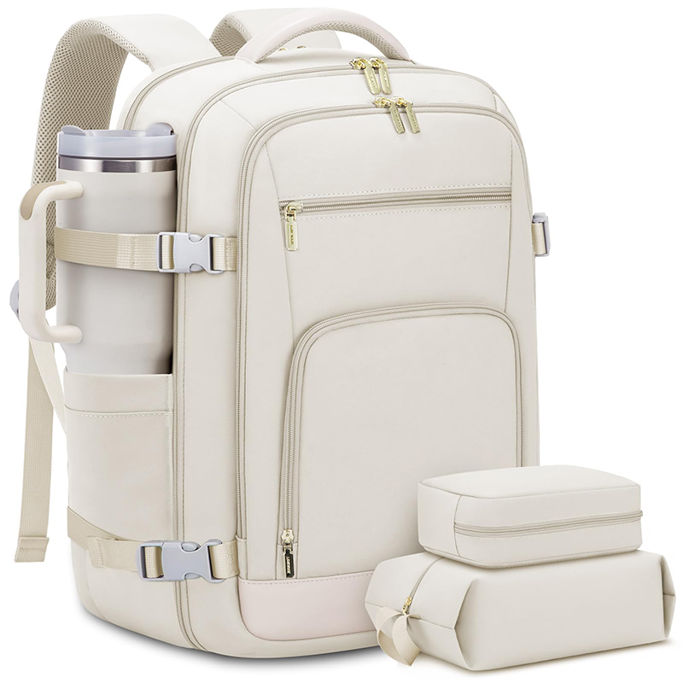 | Laptop Backpack Image 8

