Custom Sports Bags
Image | Description
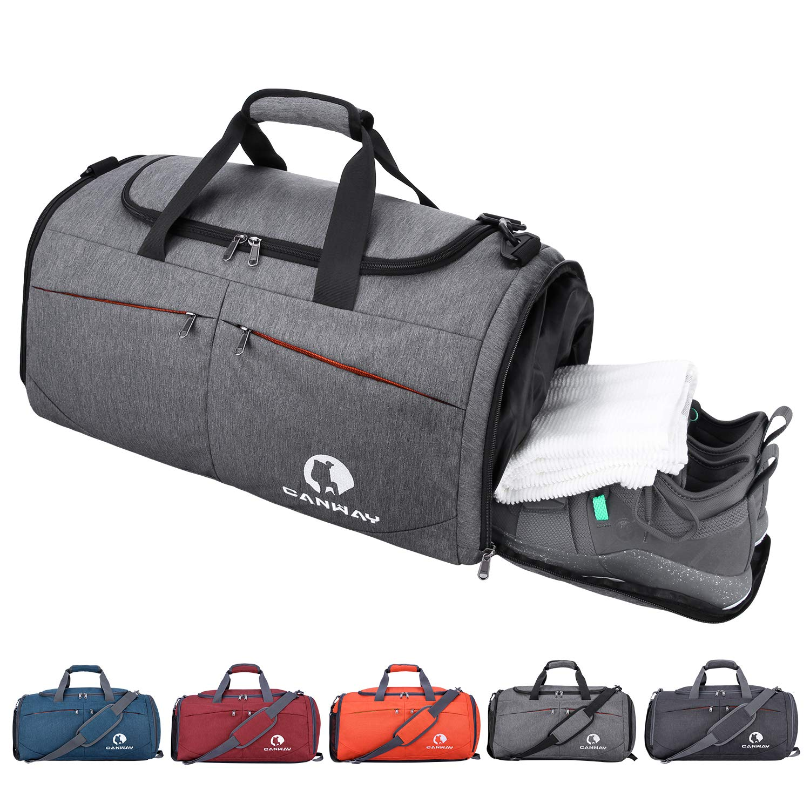 | Durable grey sports duffel bag with multiple compartments, perfect for storing shoes, towels, and clothing.
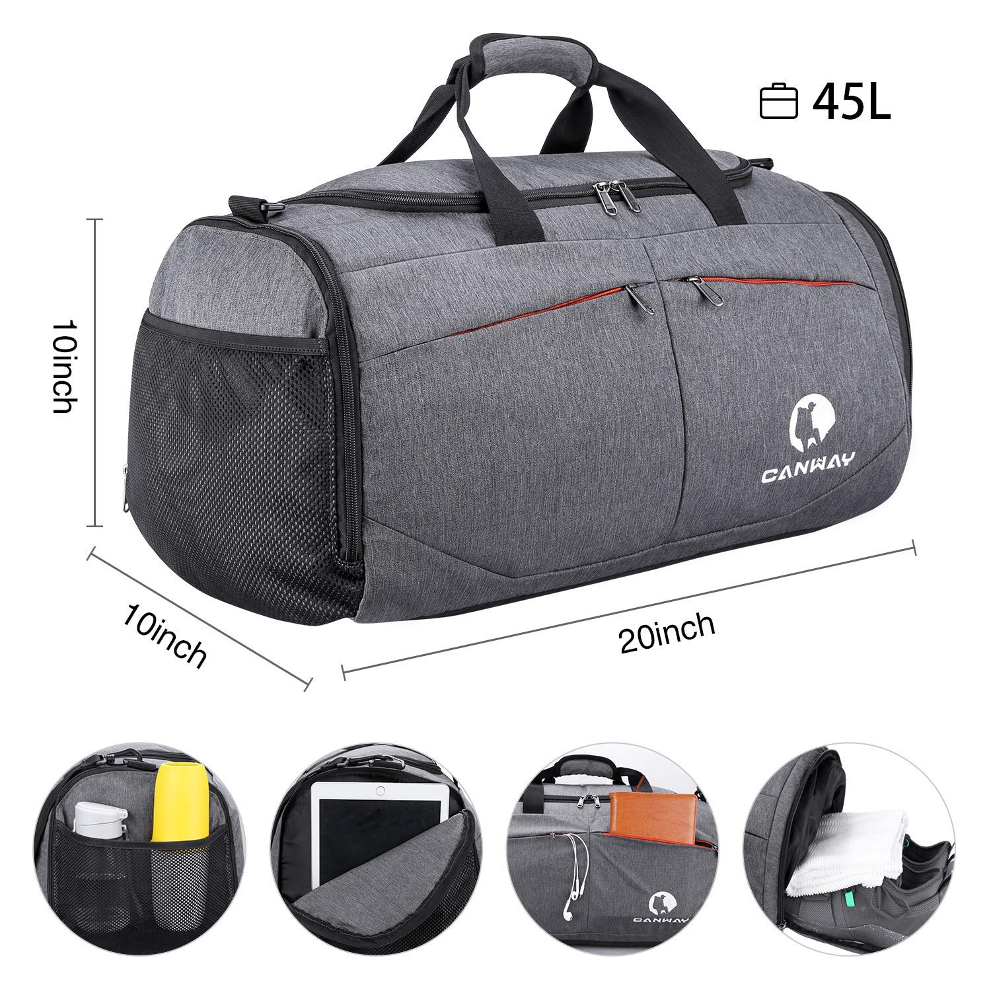 | A spacious 45L sports bag, designed for athletes to carry clothes, gadgets, and personal items, complete with mesh pockets.
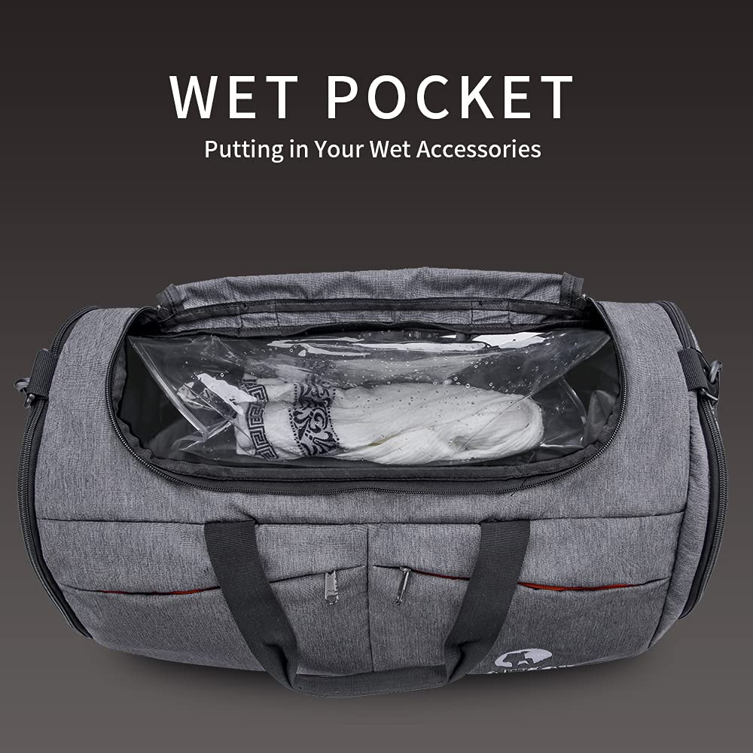 | Innovative wet pocket for storing wet clothes or gear, ensuring easy separation from dry items.
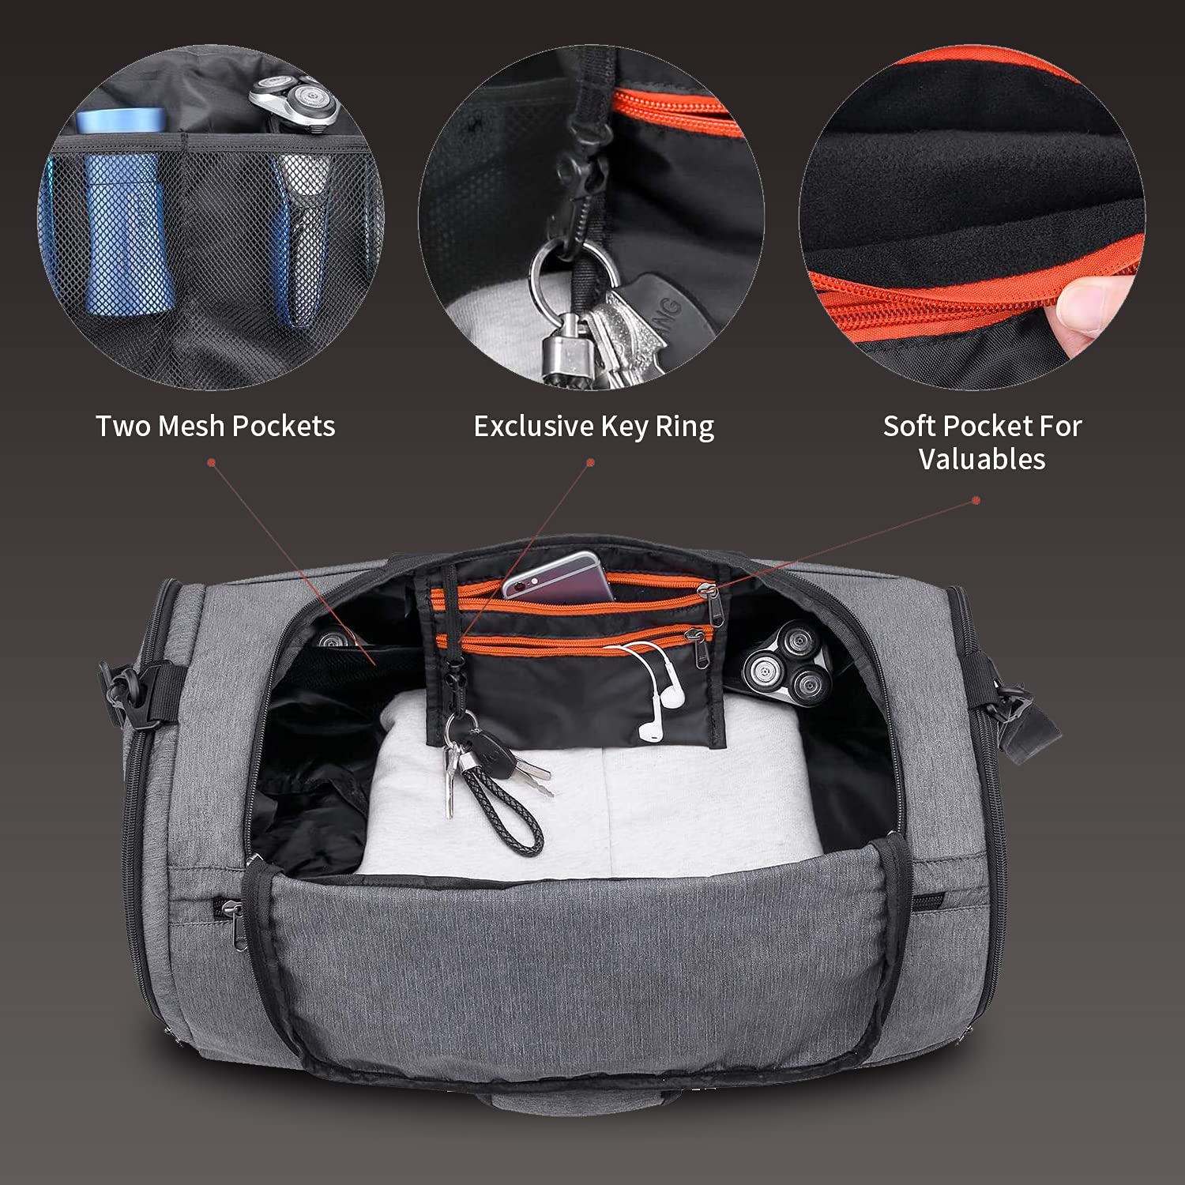 | Interior includes mesh pockets, a key ring, and a soft pocket for storing valuables, making this bag both functional and secure.
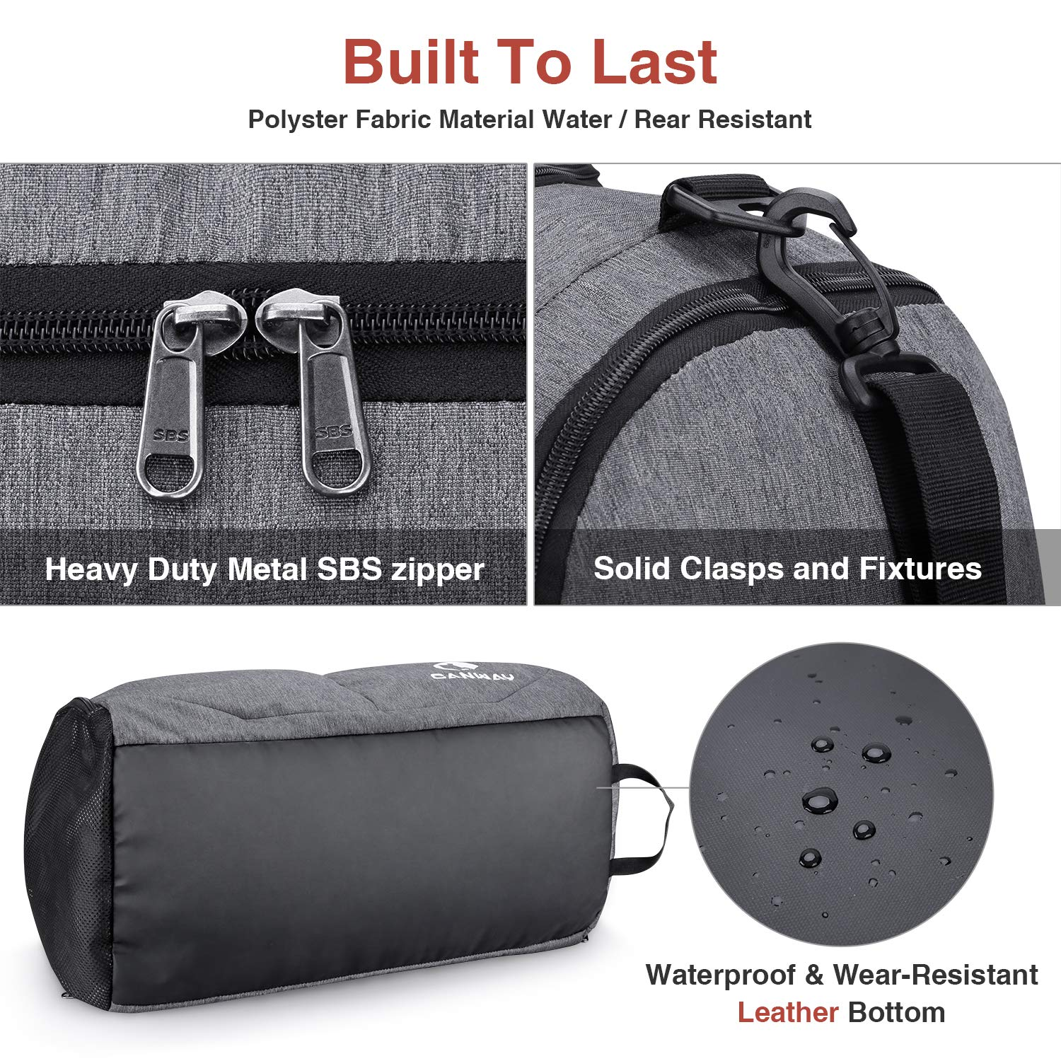 | Built with high-quality polyester fabric, the bag features water-resistant and wear-resistant leather on the bottom for durability.

