Custom Women's Bags
Image | Description
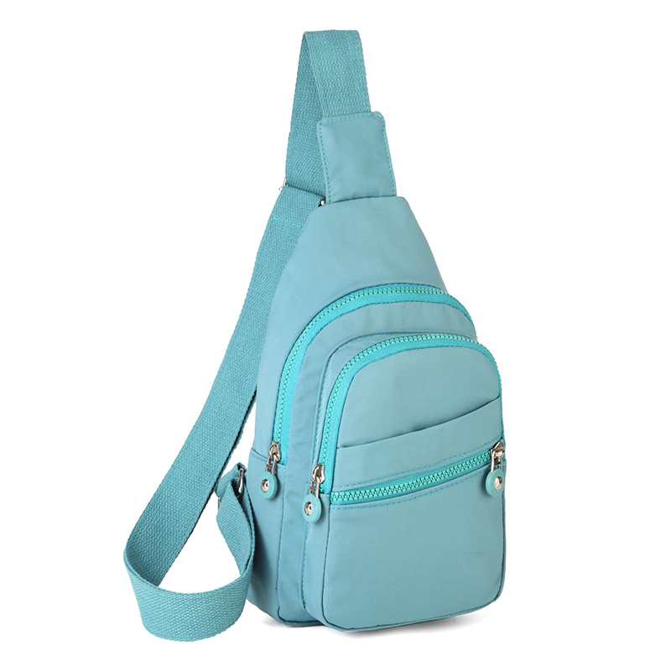 | Charming aqua sling bag, perfect for a casual day out with multiple zippered compartments.
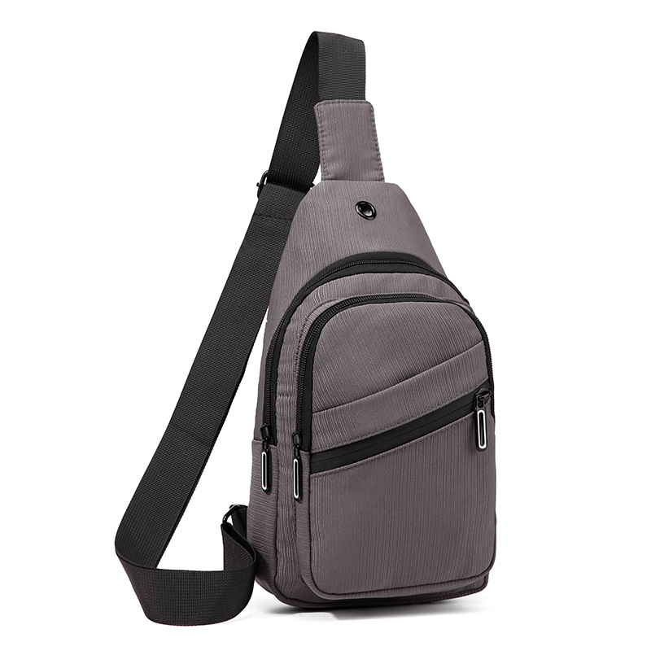 | Versatile grey sling bag designed with practicality and sleekness, ideal for everyday use.
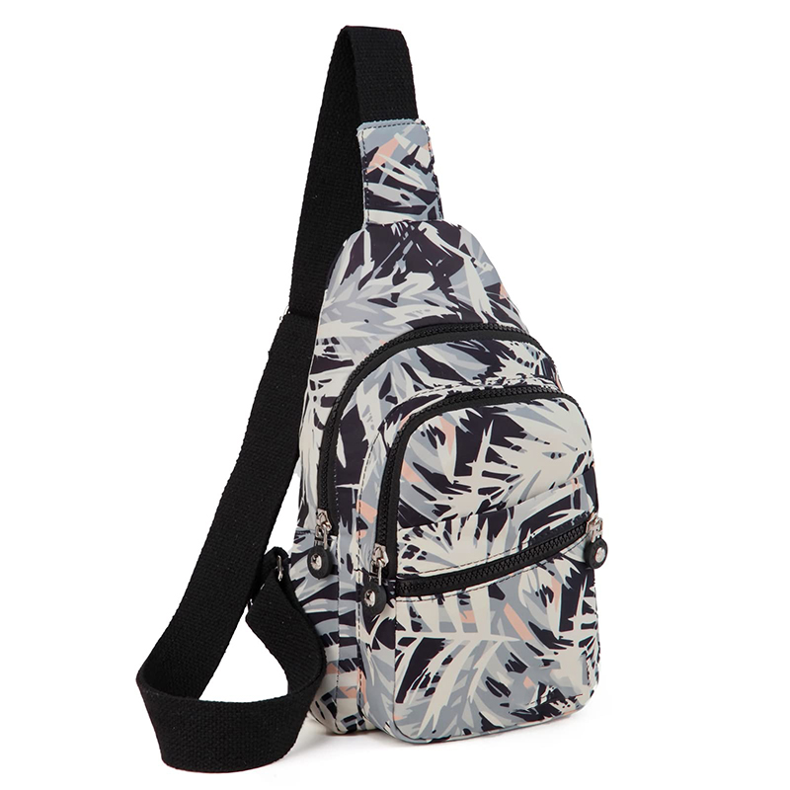 | A trendy sling bag with a chic, abstract pattern, offering both style and function.
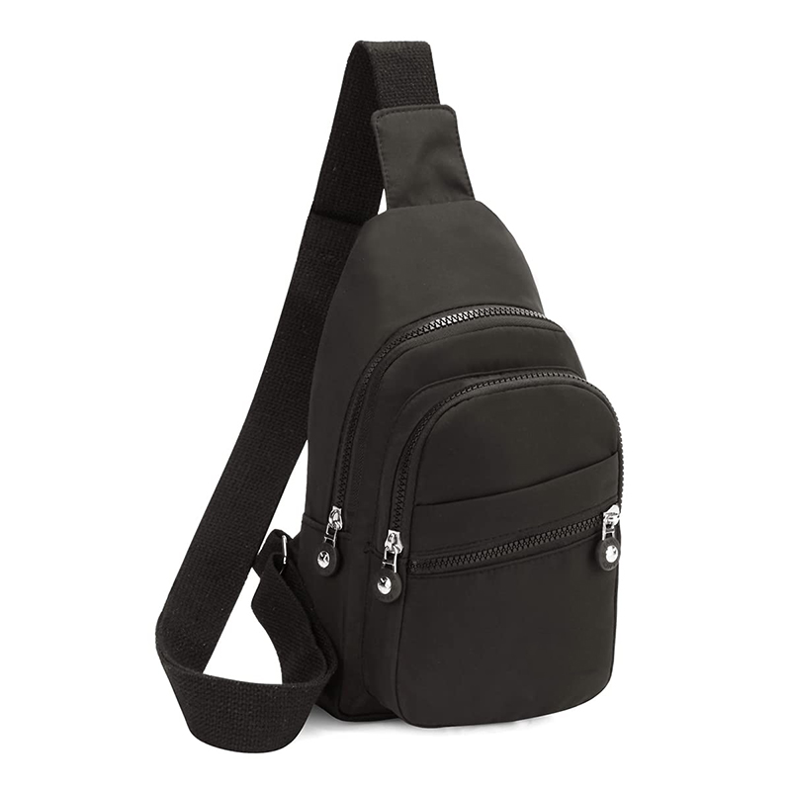 | Classic black sling bag with multiple compartments, a timeless option for any outfit.
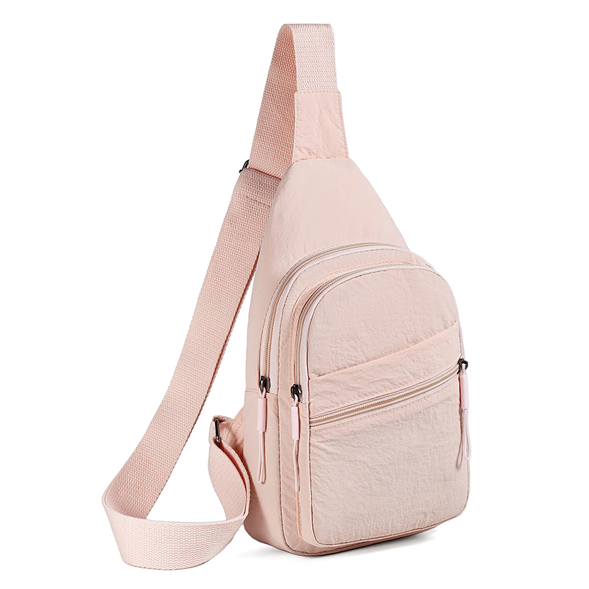 | Elegant soft pink sling bag with a minimalist design, perfect for casual and semi-formal occasions.

