Laptop Bag Product Manual
This product is a stylish and durable custom laptop bag, designed for modern professionals and students. It offers excellent protection for your laptop with its high-quality, water-resistant materials. The bag features a sleek design that fits laptops up to 17.3 inches in size. It also includes multiple compartments for organizing accessories such as chargers, cables, phones, and other essentials.
Mint Green Laptop Bag:
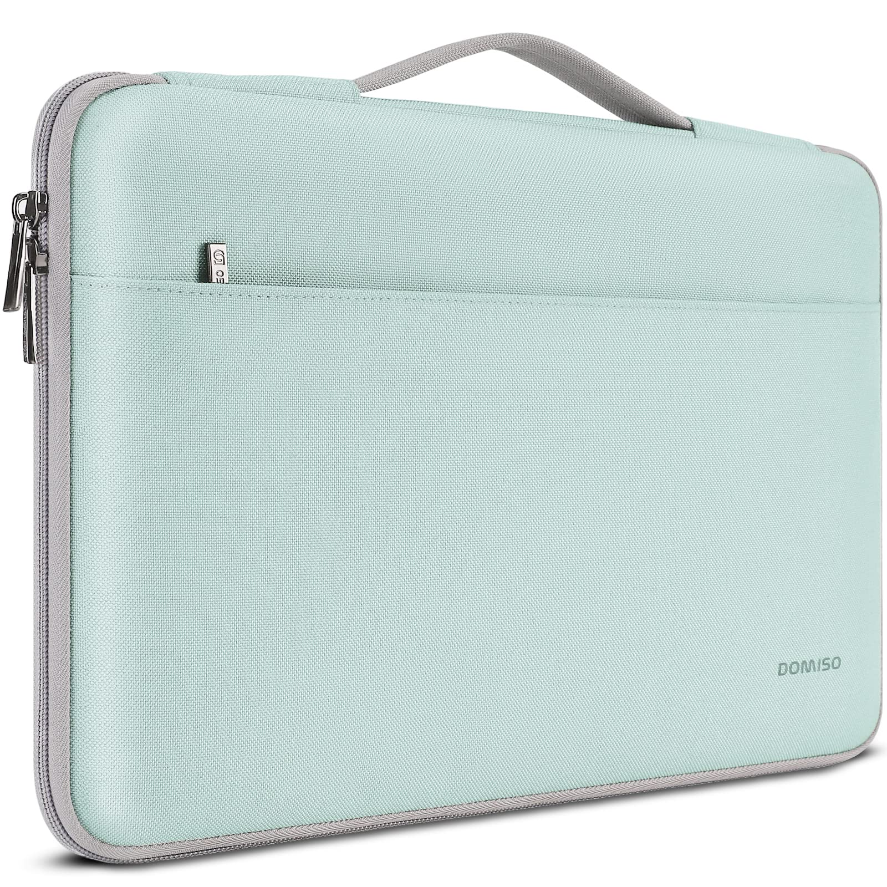
This is the mint green version of the laptop bag. It features a clean and modern look with a zippered closure and additional pocket for extra storage.
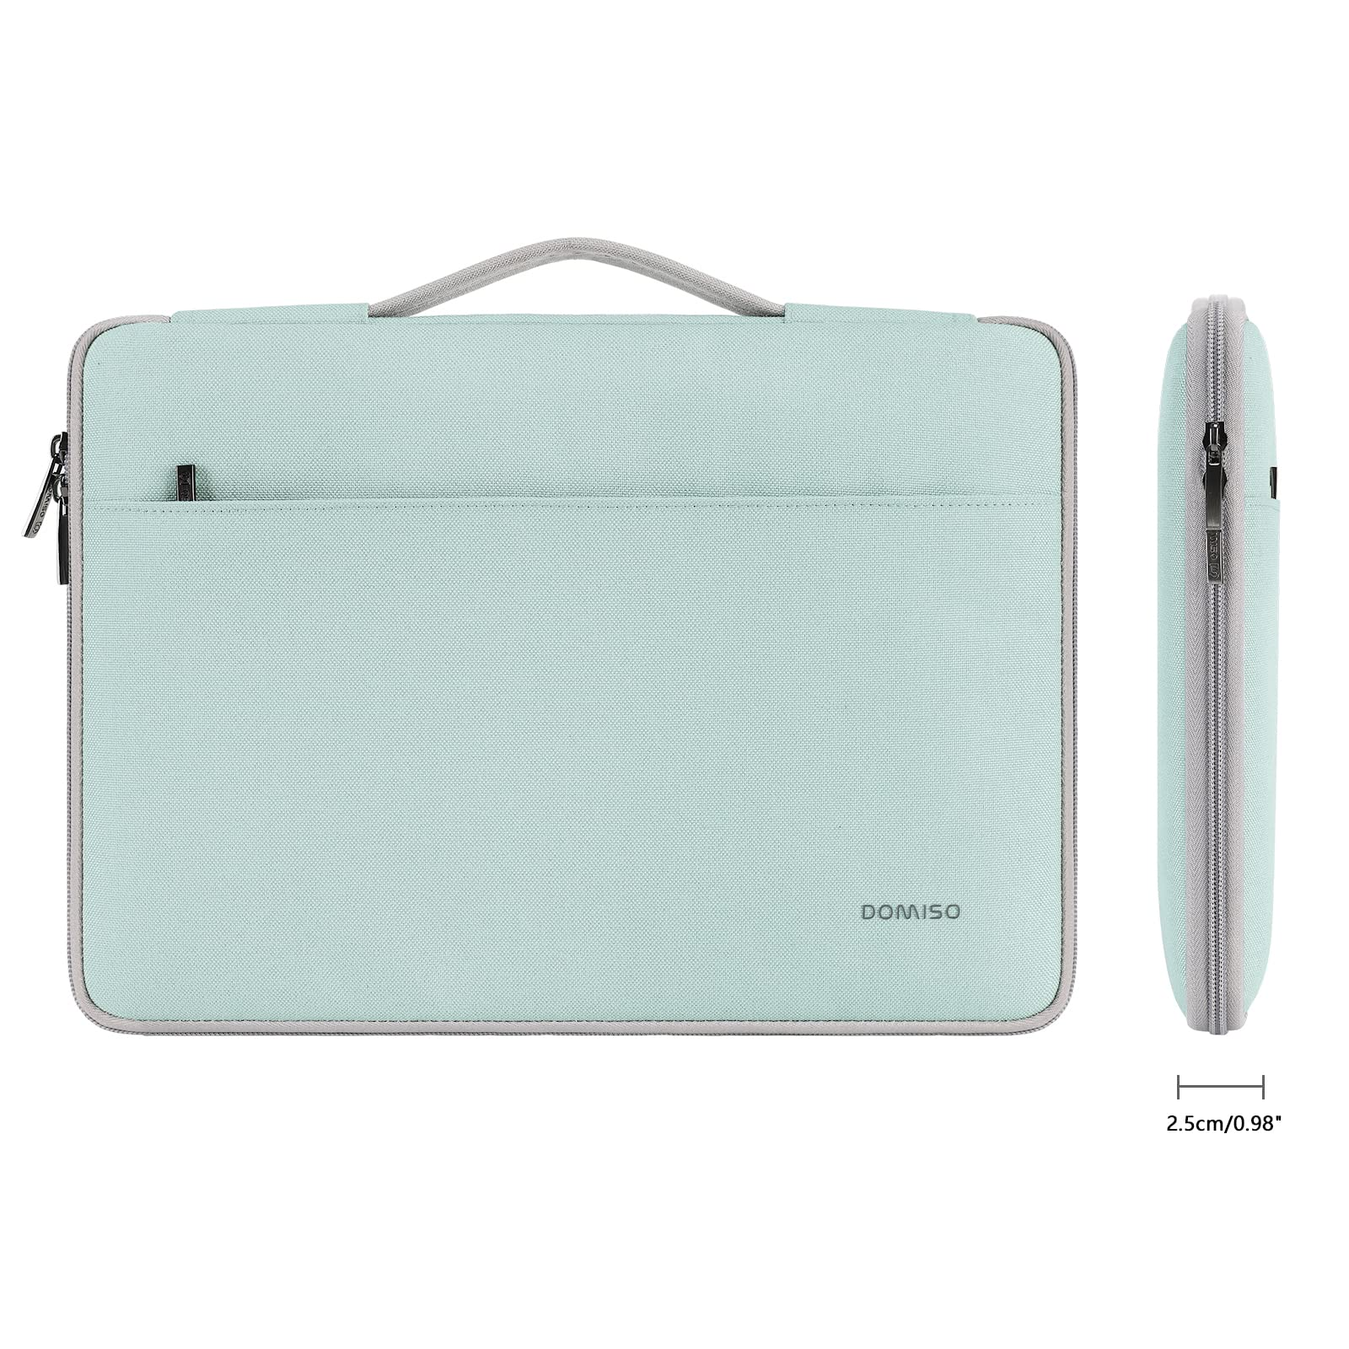
A close-up view of the bag showing the durable zipper and soft inner lining designed to protect your laptop.
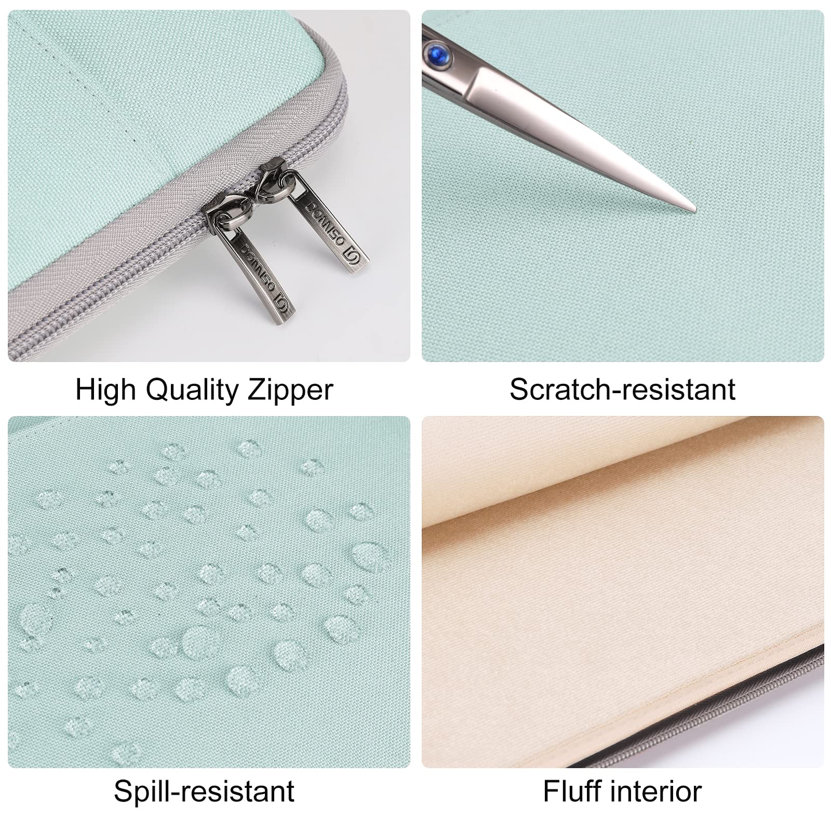
The bag’s slim design makes it perfect for easy carrying, while still providing ample space for your laptop and accessories.
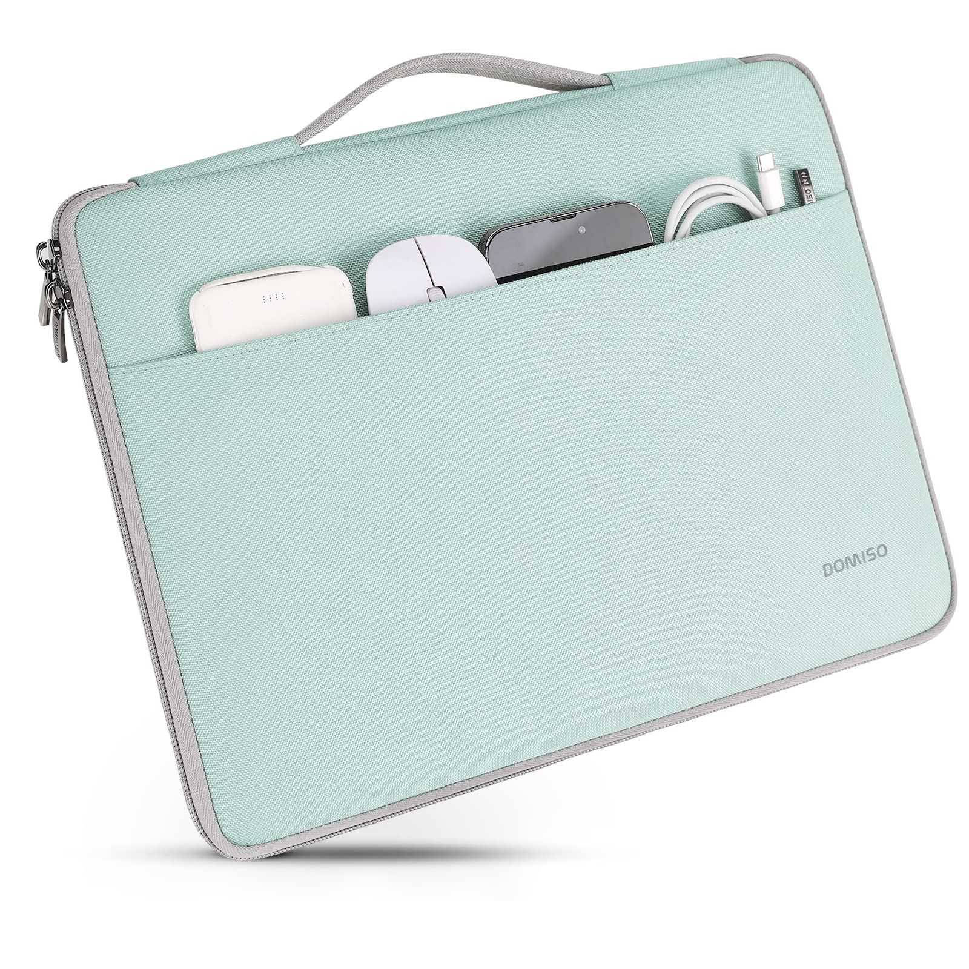
The exterior of the bag features a smooth texture, enhancing its durability and providing resistance to spills.
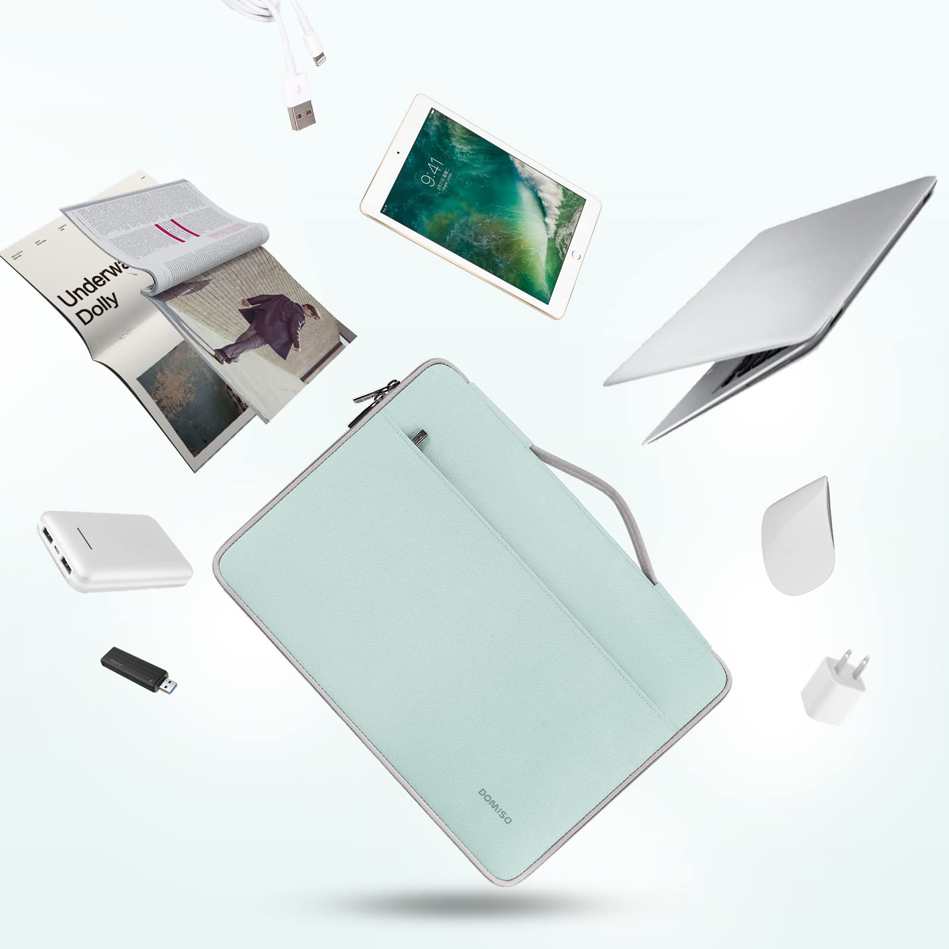
Additional compartments for storing smaller items like phone chargers and pens make the bag even more convenient.
Dark Grey Laptop Bag:
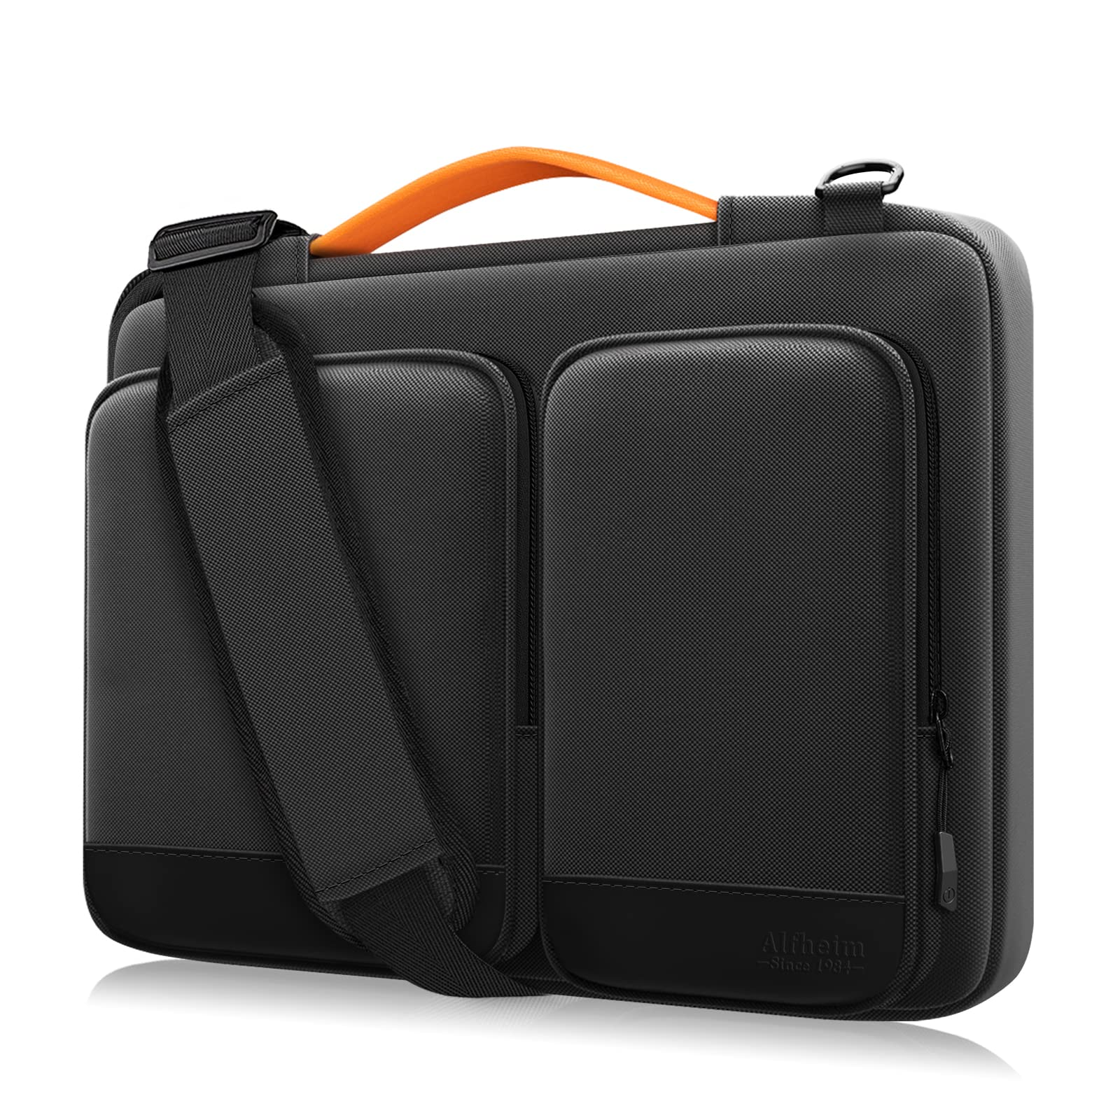
This is the dark grey version of the laptop bag, offering a more neutral tone that complements any professional setting.
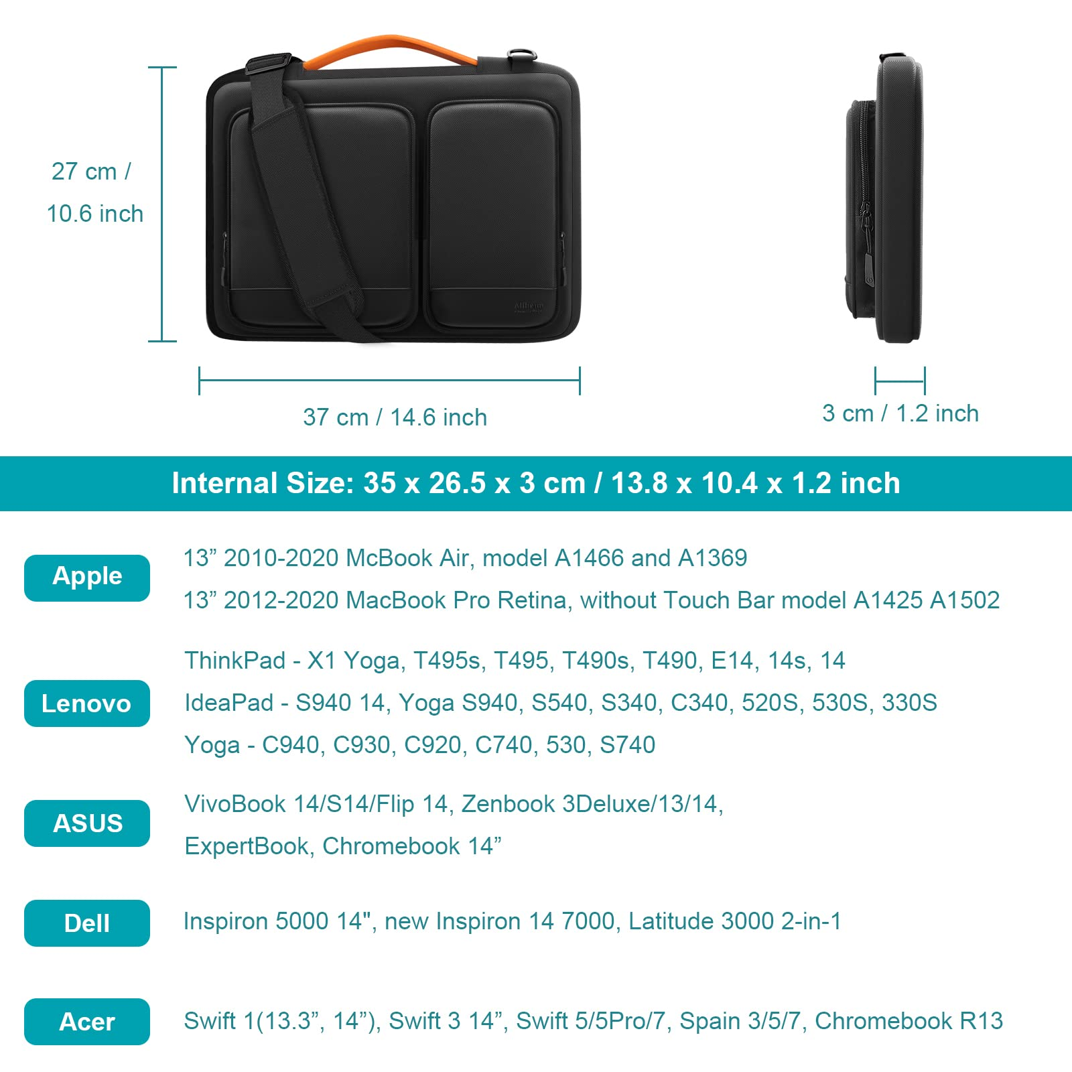
The bag is designed with padded straps and handles for comfortable carrying.
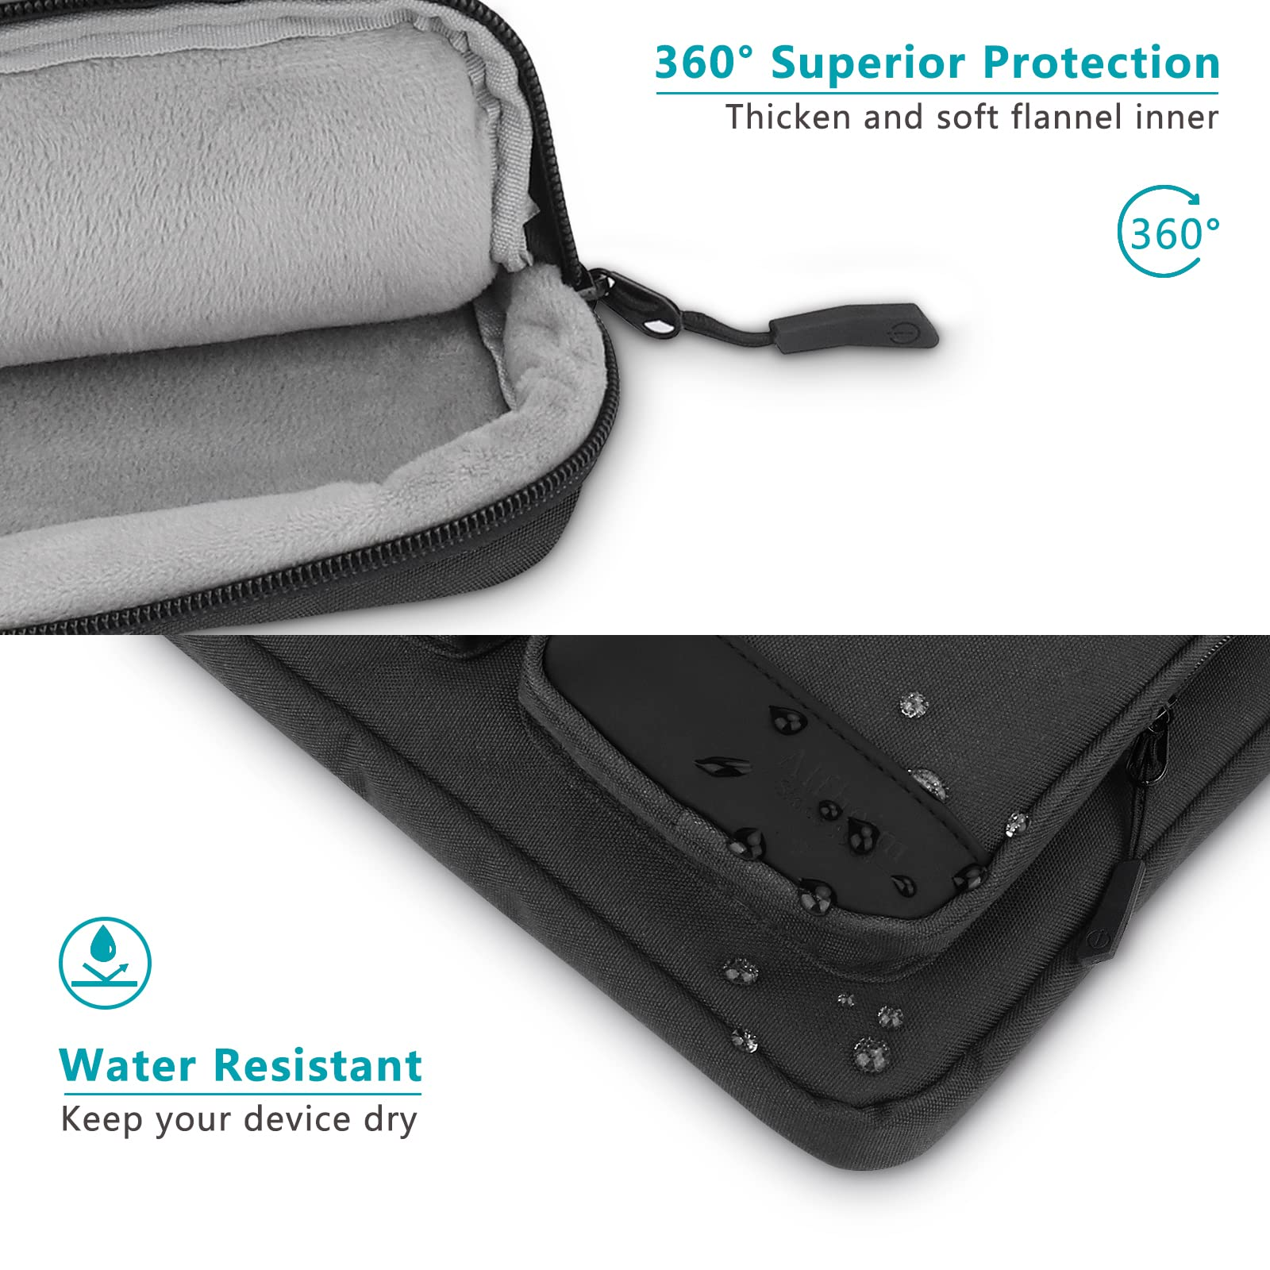
The interior is soft-lined to protect your device, and the exterior is made from a water-resistant material.
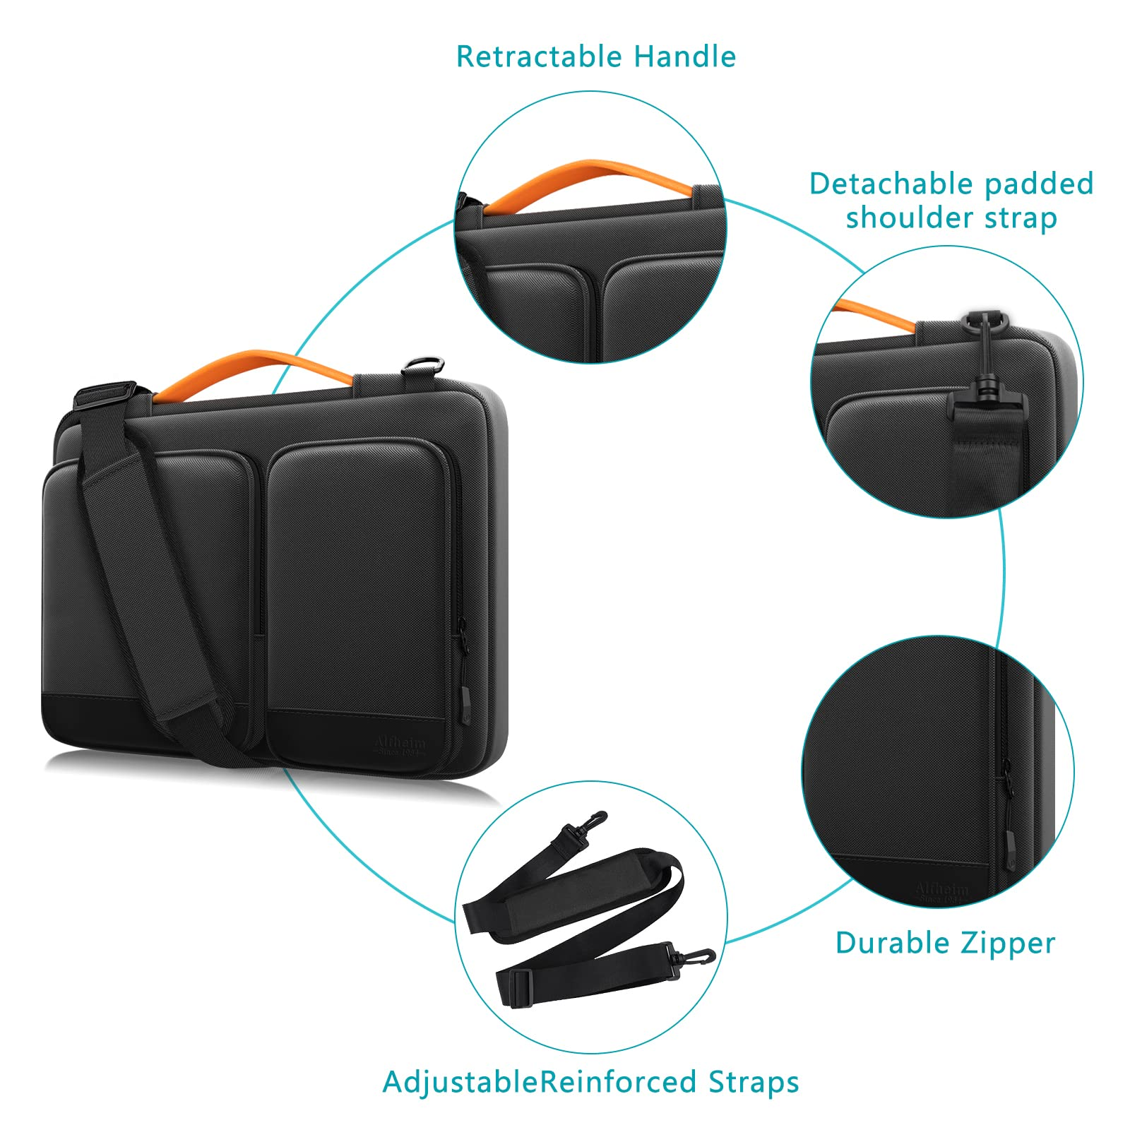
The bag includes multiple pockets for easy organization of your laptop accessories and cables.
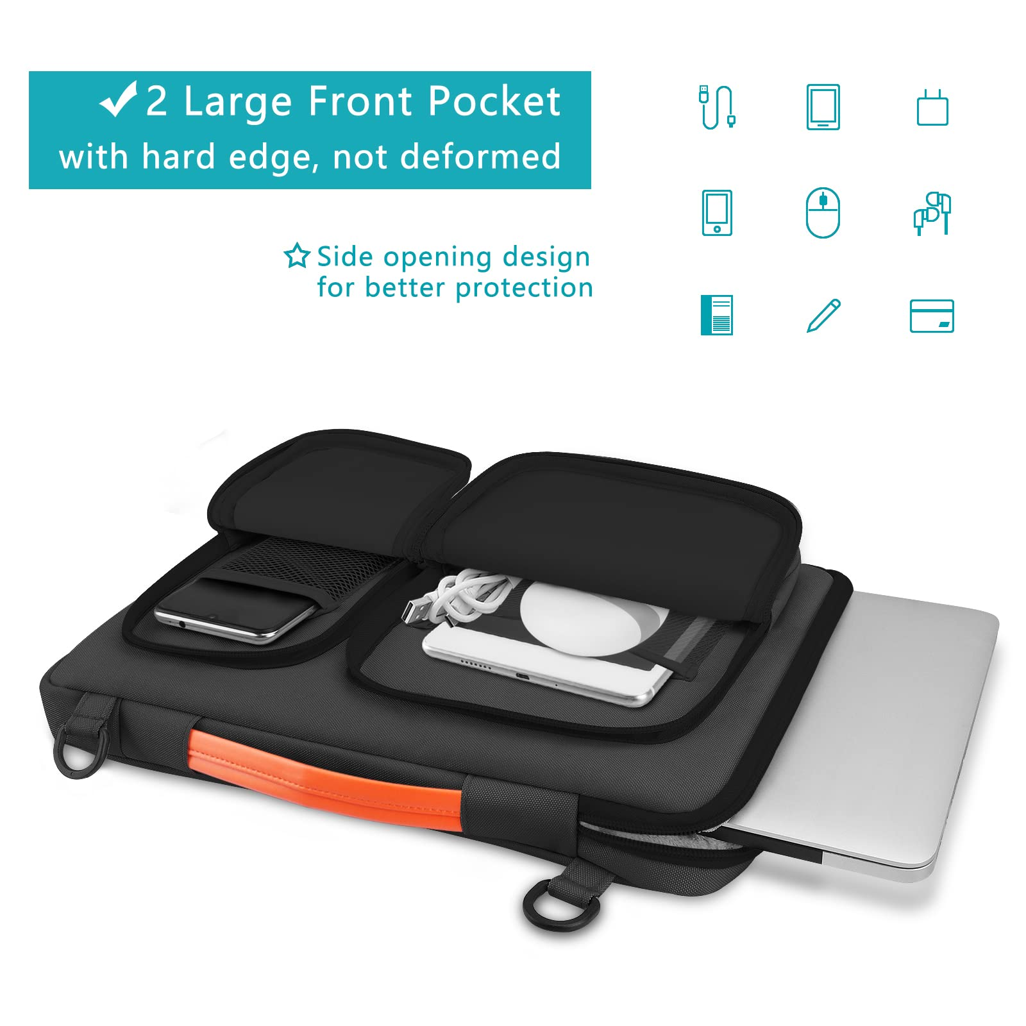
This image shows the practicality of the bag, with the ability to carry your laptop, mouse, charger, and other essentials in an organized manner.

