Product Overview - Travel Backpacks
Image | Product Details
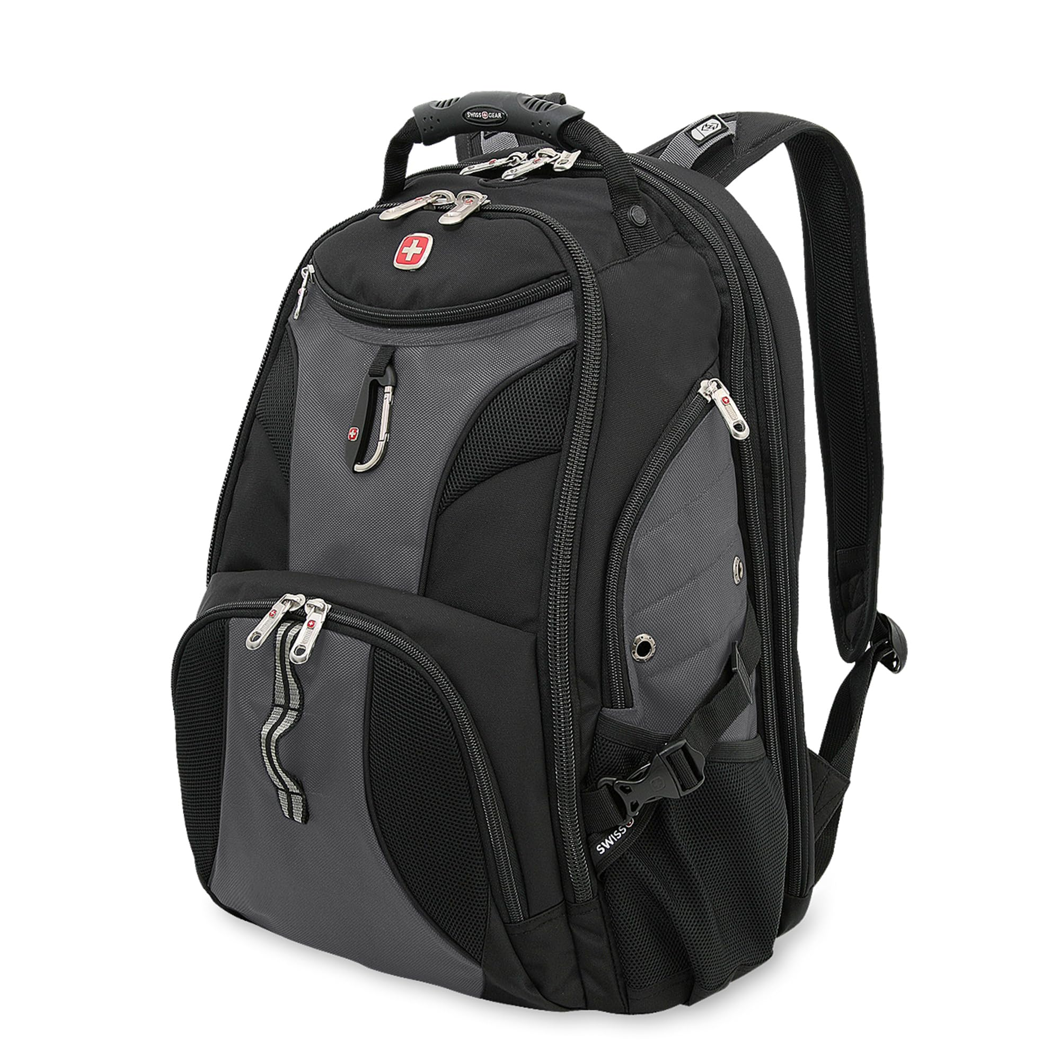 | Durably rugged polyester construction, TSA friendly with lay-flat design.
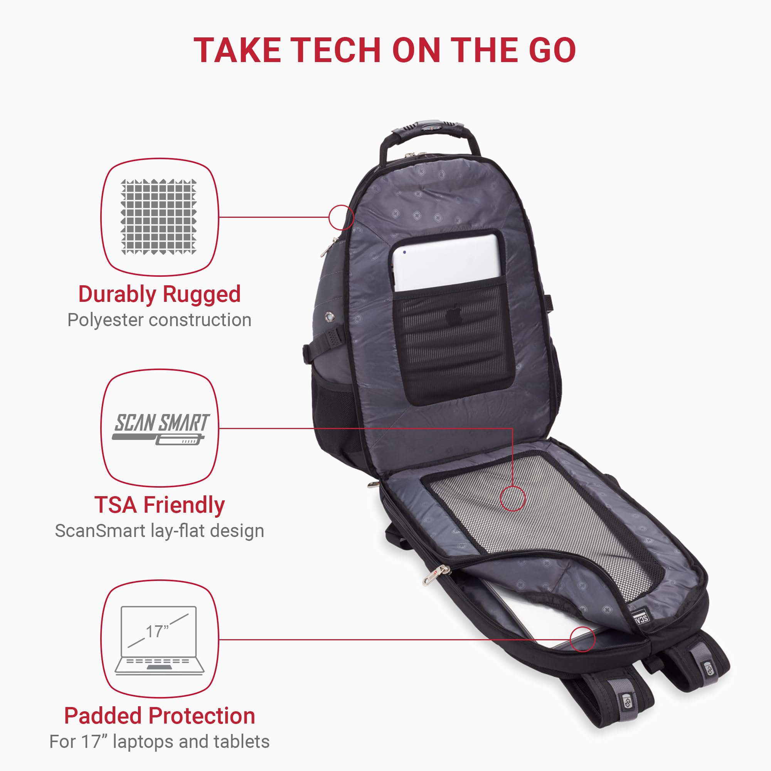 | Padded protection for 17" laptops and tablets.
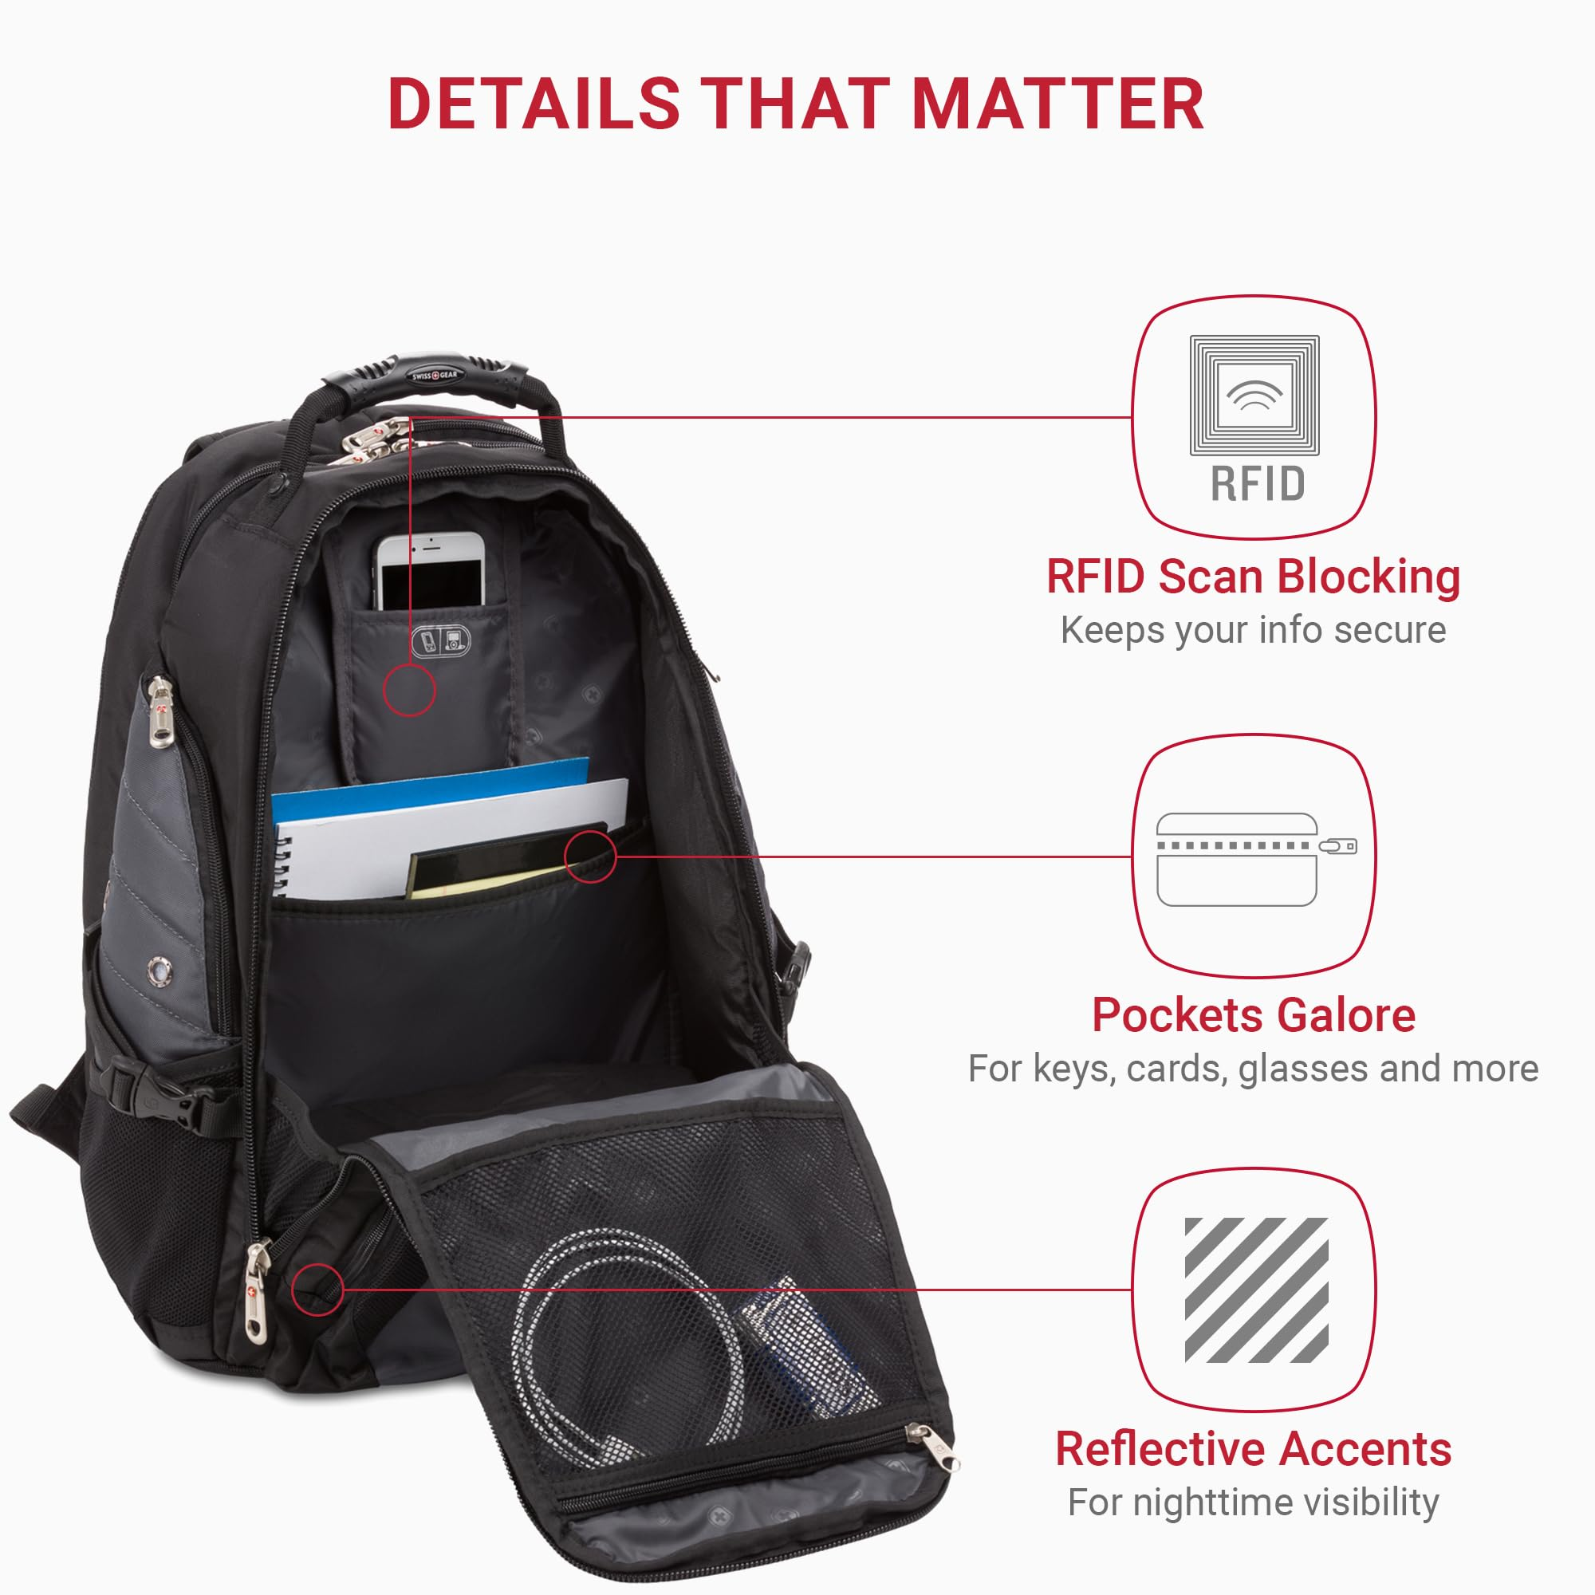 | RFID scan blocking for secure travel.
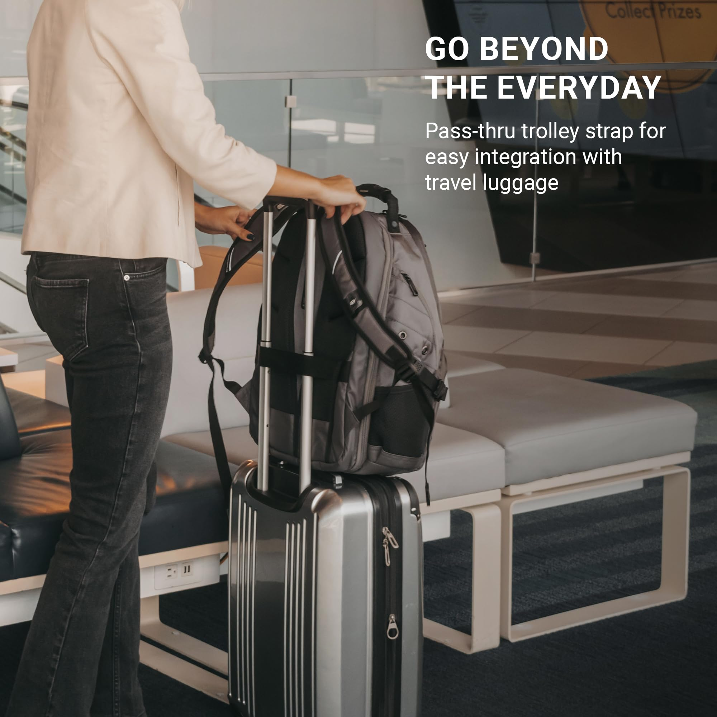 | Multiple pockets for easy organization of items.
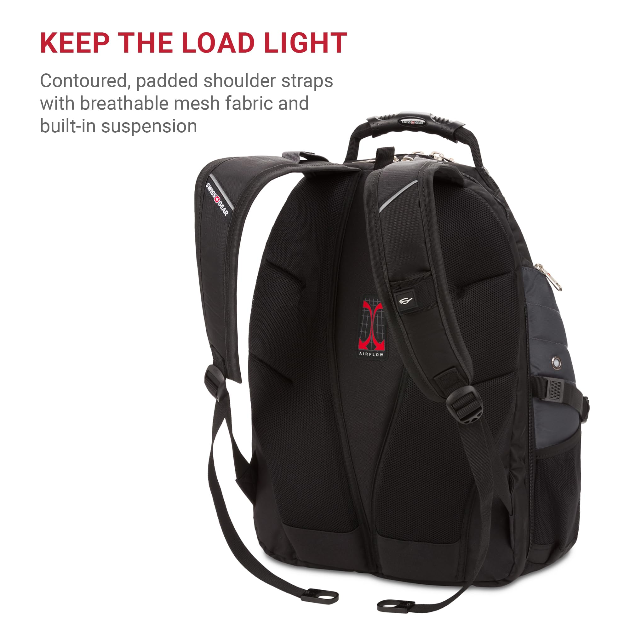 | Reflective accents for nighttime visibility.
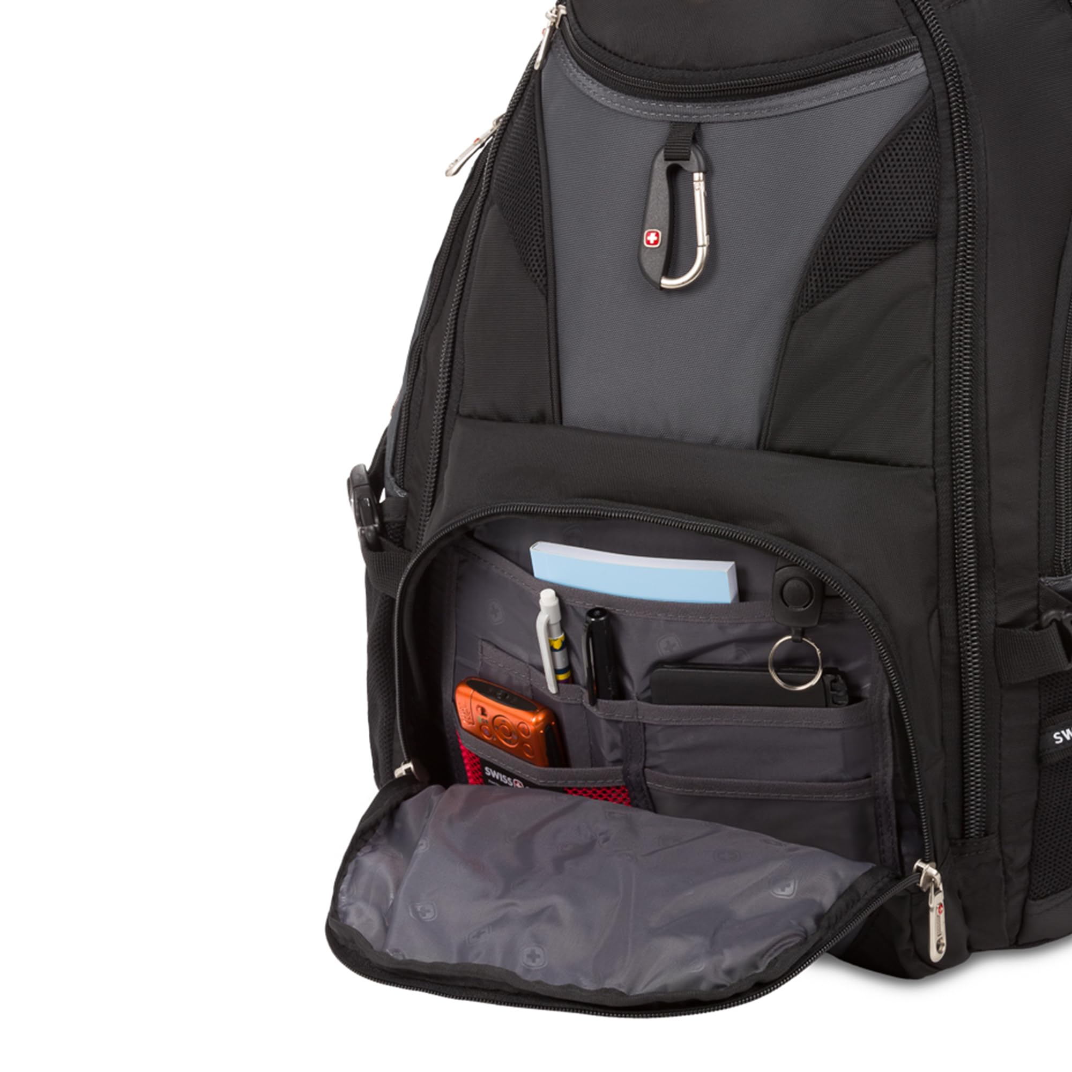 | Pass-thru trolley strap for integration with luggage.
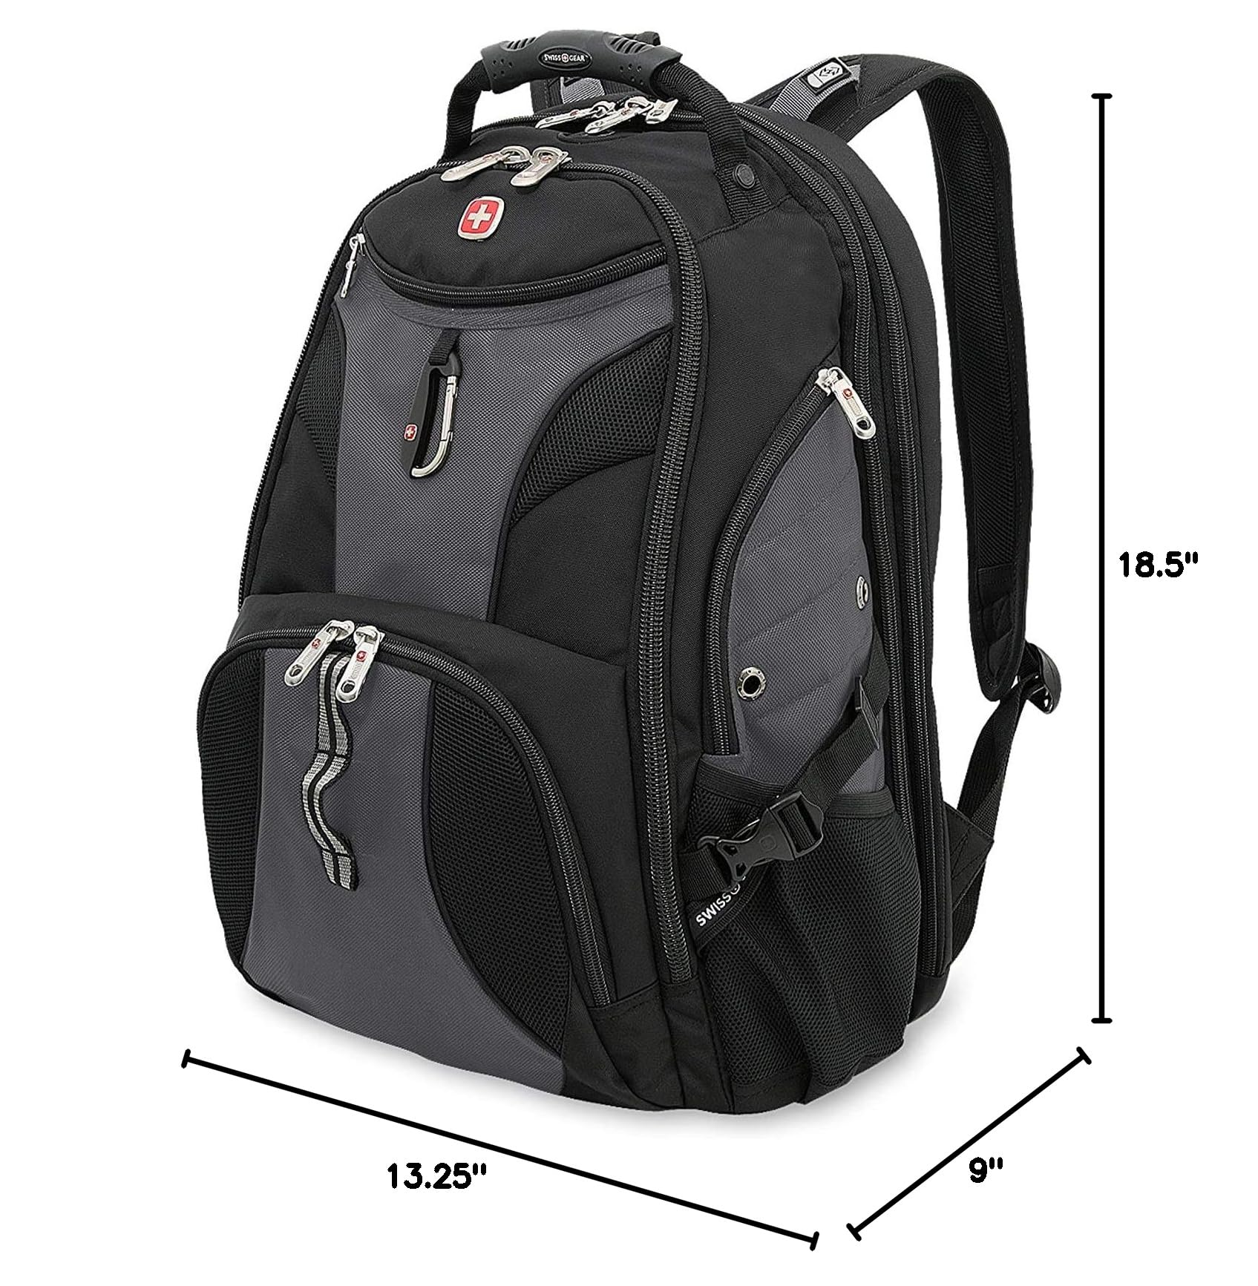 | Contoured, padded shoulder straps with breathable mesh fabric.

