Sling Bags for Women
Image | Color / Style | Description
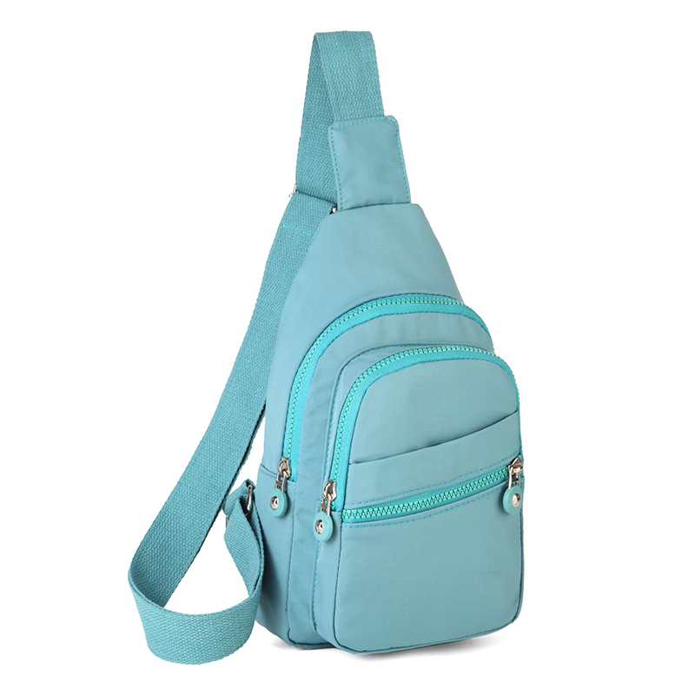 | Blue | Lightweight sling bag for women, perfect for daily use and travel.
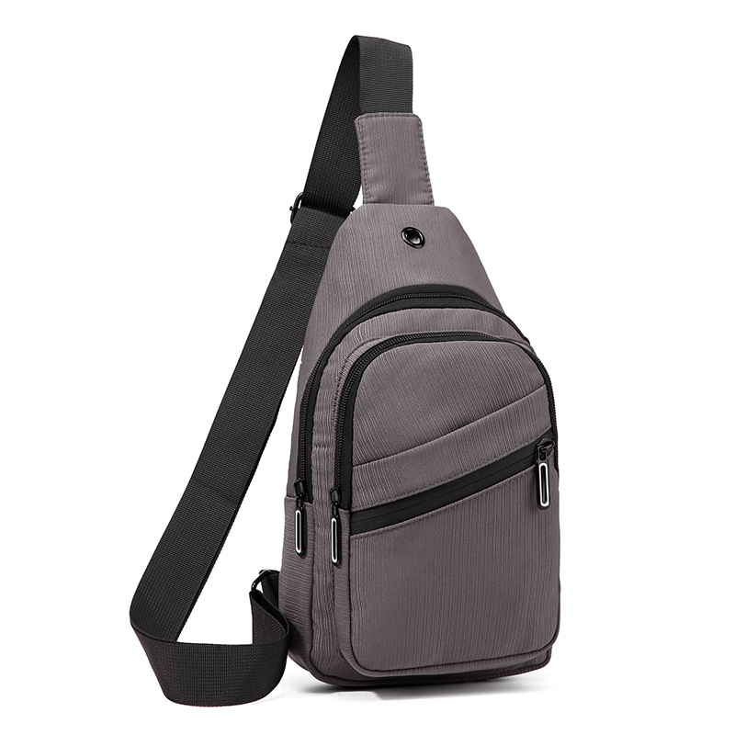 | Grey | Casual grey sling bag with multiple compartments for organization.
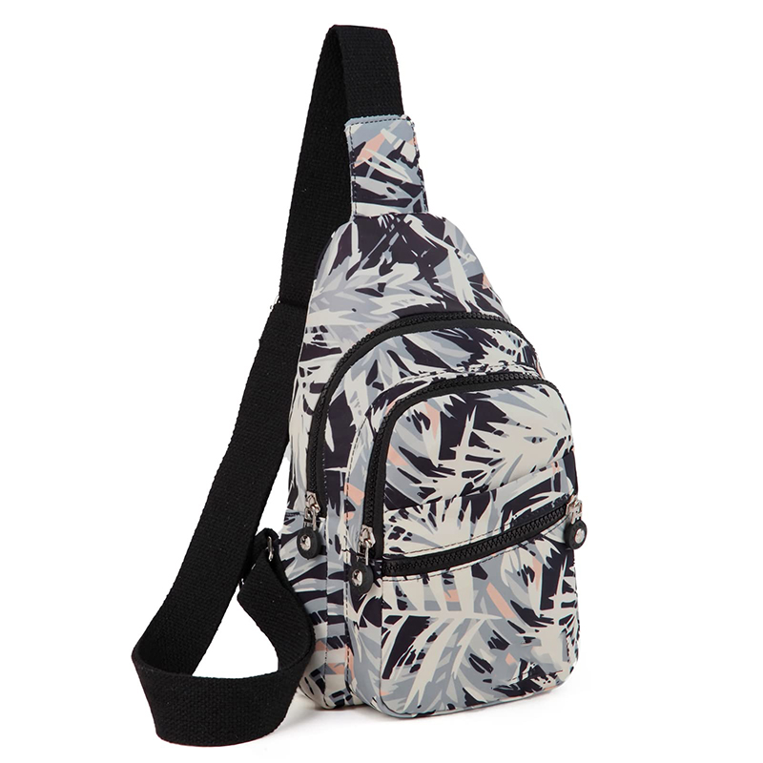 | Pattern | Trendy patterned sling bag for women, stylish and practical.
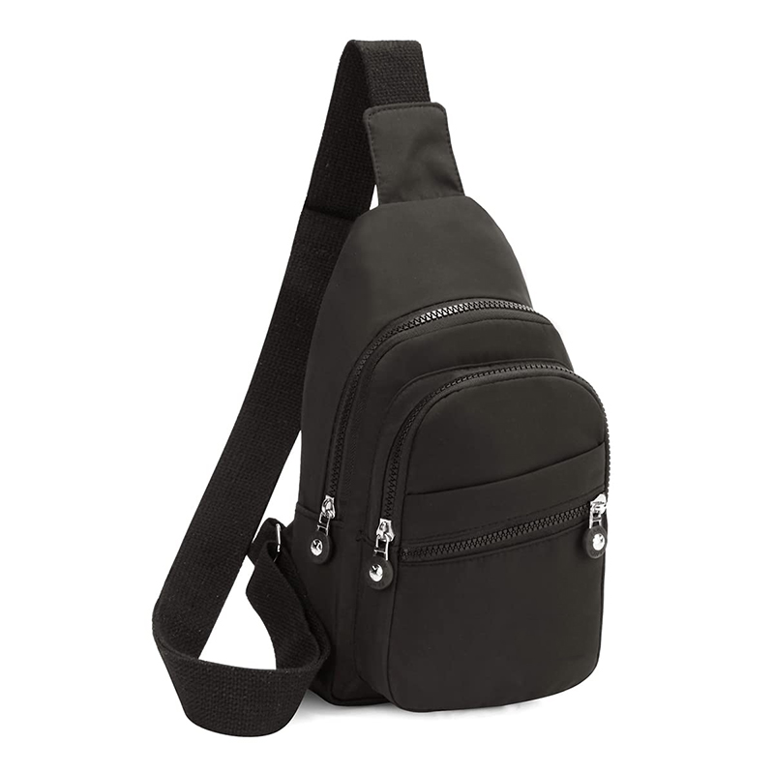 | Black | Classic black sling bag, versatile for all outfits and occasions.
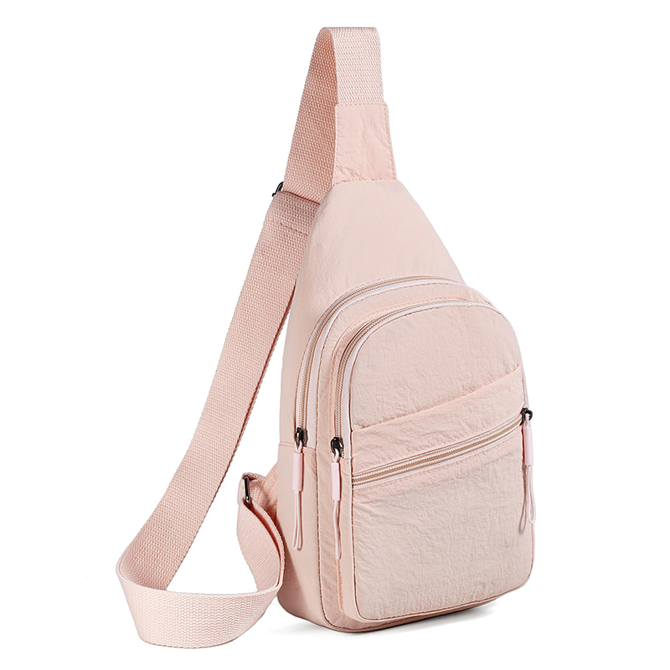 | Pink | Soft pink sling bag for women, feminine and functional.

